

USER REQUIREMENTS
DOCUMENT
FOR

NOVELS READING PLATFORM

OF
ENTREPRENEURSHIP

Version 1.0

- Ho Chi Minh, December 10th, 2025 -

Project Identification
Project Name: | Novels Reading Platform | Date: | 27/10/2025
Project Owner: | Mr. Tuan Anh Tran | Business Analyst: | Mr. Tuan Anh Tran
Post/ Rank: | Project Lzaeader | Post/Rank: | Project Leader

Revision History
Revision No. | Revision Date | In charge | Pages/Sections Revised | A*  M, D | Remarks
R01 | 27/10/2025 | anhtt | Pages 01 | A | Initialize project
R02 | 29/10/2025 | anhtt | Pages 02 | A | Create introduction
R03 | 30/10/2025 | anhtt | Pages 03 | A | Supplement  “Project background & usiness objectives”
R04 | 01/11/2025 | anhtt | Pages 07 | A | Generate “Business Objectives”
R05 | 05/11/2025 | anhtt | Pages 10 | A | Create  “Assumptions & Constraints”
R06 | 08/11/2025 | anhtt | Pages 13 | A | Draw “Context Diagram”
R07 | 11/11/2025 | anhtt | Pages 14 | A | Initialize “System User Profile”
R08 | 12/11/2025 | anhtt | Pages 17 | A | Create IV.1  “List of Business Process”
R09 | 13/11/2025 | anhtt | Pages 18 | A | Create Use Case Diagram  ( iv.2.1, iv.2.2)
R10 | 14/11/2025 | anhtt | Pages 20 | M | Supplement Use Case Diagram( iv.2.3)
R11 | 17/11/2025 | anhtt | Pages 22 | A | Generate & Draw Use Case Diagram( iv.2.4)
R12 | 18/11/2025 | anhtt | Pages 23 | A | Generate  “IV.3 High-Level Process Flow”
R13 | 19/11/2025 | anhtt | Pages 26 | M | Supplement Swimlane diagram (iv.3.1, iv.3.2, iv.3.3, iv.3.4)
R14 | 20/11/2025 | anhtt | Pages 31 | A | Initialize “Detailed BPMN Diagram  (iv.4.1)
R15 | 22/11/2025 | anhtt | Pages 35 | A | Define BPMN completed
R16 | 25/11/2025 | anhtt | Pages 23 | M | Fixed missing use cases in BP
R17 | 26/11/2025 | anhtt | Pages 53 | A | Initialize “Functional Requirements”( v.1)
R18 | 27/11/2025 | anhtt | Pages 65 | A | Generate “Functional Requirements”(v.2)
R19 | 28/11/2025 | anhtt | Pages 70 | A | Create “Non- Functional Requirements” (vi.1)
R20 | 30/11/2025 | anhtt | Pages 74 | A | Completed 20 first Non Functional Requirements description
R21 | 01/12/2025 | anhtt | Pages 90 | M | Done the rest of Non Functional Requirements description
R22 | 01/12/2025 | anhtt | Pages 103 | A | Add “Quality Attribute” (vi.3)

Distribution List
Name | Post/Rank | B/D | Start Date | End Date
Tuan Anh Tran | Project Leader | Business  Analysis &Design | 08/09/2025 | 02/12/2025
Minh Huy Nguyen | IT Lead | Development Department | 08/09/2025 | 02/12/2025
Nhat Nam Vu | Member | Development Department | 08/09/2025 | 02/12/2025
Le Khang Nguyen | Member | Multimedia & Communications | 08/09/2025 | 02/12/2025
Hong Ha Bui | Member | Multimedia & Communications | 08/09/2025 | 02/12/2025
Khanh Thu Pham | Member | Digital Art Design | 08/09/2025 | 02/12/2025

Table of Contents
I. INTRODUCTION 7
I.1 Purpose 7
I.2 Project Background 8
I.3 Business Objectives 8
I.4 Project Scope 9
I.4.1 In Scope 10
I.4.2 Out of Scope 10
I.4.3 Supporting Scope 10
I.5 Project Objectives 10
II. IDENTIFIED RISKS, ASSUMPTIONS AND CONSTRAINTS 11
II.1 Identified Risks 11
II.2 Assumptions 12
II.3 Constraints 14
III. PROPOSED SYSTEM OVERVIEW 16
III.1 Description of Proposed Novels Reading Platform 16
III.2 System User Profile 18
IV. FUTURE BUSINESS PROCESS 20
IV.1 List of Future Business Process 20
IV.2 Use Case Diagram (Overview) 22
IV.2.1 Purpose 22
IV.2.2 Actors Identified 22
IV.2.3 Overview 23
IV.2.4 Use Case Grouping 24
IV.3 High-Level Process Flow 26
IV.3.1 Purpose 26
IV.3.2 Actors / Lanes 27
IV.3.3 Swimlane Diagram 28
IV.4 Detailed BPMN Diagram 34
IV.4.1 BPMN – Login & Registration Process 35
IV.4.2 BPMN – Content Discovery, Reading & Feedbacks Process 41
IV.4.3 BPMN – Contents Creation & Moderation Process 45
IV.4.4 BPMN – Subscription, Purchasing & Payment Process 51
V. FUNCTIONAL REQUIREMENTS 55
V.1 List of Functional Requirements 55
V.2 Detailed Functional Requirement Specifications 57
VI. NON-FUNCTIONAL REQUIREMENTS 72
VI.1 List of Non-Functional Requirements 72
VI.2 Detailed Non-Functional Requirement Description 75
VI.3 Quality Attributes Compliance Matrix 108
VII. APPENDICES 114
VII.1 Glossary of Terms 114
VII.2 Reference Documents 115
VII.3 Requirement Traceability Matrix (RTM) 115
VII.4 Document Approval Signoff 116

- INTRODUCTION

I.1 Purpose
This User Requirements Document (URD) is written with a view to defining as well as describing the indispensable user and business requirements for the proposed Novels Reading Platform.
The information emphasised thorough document plays a vital role in serving as a communication bridge between Business users and the Development team, supplementing a robust understanding of objectives, functionalities, constraints as well.
The intended audience includes business stakeholders, project manager, business analyst, and development team.
The document is going to be used ultimately as the basis for subsequent development tasks comprising design, implementation, testing to verify that the system meets the user’s business demands precisely in advance of publishment, upgrades or maintenance one day.

I.2 Project Background
Over the past few years, the readers could adaptly access to the reknown novels reading platform from every aspects of the Internet space. Nevertheless, these of whom still get difficulties in choosing the truly reading platform for gathering a long time because of the fact that each of platform has the similar pattern as well as novels published concurrently or even the copying situation took place in seems to be unavoidable. It has already violated seriously to business morality field and left the strongly consequences of suspicion and belief to the readers.
First and foremost, to the “Inkrealm” platform which is going to offer the comprehensive resolutions of matters indicated below. The iconic difference of this one from the others is that this platform would focus on the genZ generation, especially in Asia. Based on the statistics of novels reading posted on Goodreads in region, the average age from 15 to 30 would definitely have enthusiastic in spending time in reading rather than the other activities. The Goodreads has also pointed out that the entertaining industry of reading would be remarkly predictable one when it is going to contribute billions dollar on entertainment online social field.
The strictly violation in business morality must be condemned strongly. To resolve thoroughly this issue, “Inkrealm” has joined hands with the publishers, writers with the long-standing experiences in moderating contents, novels obviously. Each newly published novel or chapter is strictly reviewed for authenticity and copyright compliance.
Moreover, AI trending has already had appearances in every aspect of the social living. That’s why the integration in platform is looking forward to being one of the most predictably innovative solutions in this age. The readers nowadays could find out the favor novels our their own based on the users behavior, demand and prosensity remarked on platform. All of these have the robust supporting by AI which our high-experienced team has implemented for over years in many fields from medical to education and so on. Instead of reading by original way, the platform also offers the reading speechs based on users’ requirements with the unlimited choices which might open unprecedented experience in advance.
In conclusion,, “Inkrealm” platform is published with a ultimate view to serving the impressive users’ experience in reading entertainment field which might build up the mutal understanding even so mitigate the pressure inside without talking out. From then, the violation of business morality would reduce much more expectable than the previous one that contribute not only the treasure but also the truly belief in the social Internet space.

I.3 Business Objectives
The “Inkrealm” platform is built up to accomplish the following business objectives:
- Upgrade subscription conversion rate by 25% within six months of launch.
- Mitigate copyright violation incidents at least of 90% through verified content moderation workflows.
- Increase user engagement by 40% through AI-based personalized recommendations.
- Improve operational efficiency with automative 40% of moderation process.
- Enhance system performance with 10,000 users concurrently in the real-time scenarios.
- Establish trust and publishing standards within the online reading community.
- Attract at least 100,000 users for there months after launch.
- Achieve a minimum 85% customer satisfaction target and 58% retention rate within the first operational year.
- Integrate multiple distinct payment gateways to ensure fast transaction processing, providing users with a seamless and flexible payment experience within 1-3 minutes.

I.4 Project Scope
The “Inkrealm” platform would offer the principal features listed below:

I.4.1 In Scope
- Content Management: Enable authors/writers and authorized editors to create, update, and delete novels and chapters with verified and approved content.
- Subscription & Promotion: Provide multiple subscription packages, with regular voucher-based discounts for users.
- Personalization & User Experience: Offer customizable interface themes (dark/light modes), personalized settings, and adaptive reading preferences.
- AI Recommendation Engine: Integrate an AI-powered recommendation system to analyze user behavior and deliver personalized novel suggestions in real time.
- Q&A Handling: Provide responsive assistance to user inquiries during office hours (8:00 AM – 5:00 PM) via integrated Q&A feature, ensuring concise and adaptive responses to user issues.
- Maintenance Support: Conduct scheduled maintenance activities every Thursday from 9:00 AM to 1:00 PM within 3 months after launch to ensure stable operation.

I.4.2 Out of Scope
- Integration with non-partner or unauthorized third-party content providers.
- Development of mobile native applications in this initial release phase (web-based version only).
- Integration with advanced or non-standard payment gateways beyond the initial release scope.

I.4.3 Supporting Scope
- Community Engagement: Collaborate with recognized influencers and reading communities to promote brand awareness and drive user engagement.
- Advertising monetization related to influencer collaborations.

I.5 Project Objectives
The “Inkrealm” platform would be implemented with a view to achieving these obvious project objectives indicated below:
  - Partner with verified writers and publishers to implement content moderation and reduce copyright violations by at least 90%.
  - Achieve 10,000 active users within 6 months after launch with a 70% monthly retention rate.
  - Maintain system stability by performing scheduled maintenance every Thursday during the first 3 months post-launch, ensuring consistent operational performance.
  - Develop AI-powered recommendation and translation modules to analyze user behavior and deliver personalized novel suggestions in real time.
  - Introduce multi-tier subscription packages and voucher-based discounts, enabling users to select flexible pricing options and enhancing platform competitiveness.
  - Integrate robust internal & external payment gateway to improve user convenience and support fast payment confirmation within 3–5 minutes.

- IDENTIFIED RISKS, ASSUMPTIONS AND CONSTRAINTS
The followings are the identified risks, assumptions and constraints which have have tightly relationship with requirements defined at this stage from business users and the stakeoholders involved.

II.1 Identified Risks
The list of identified risks for the project is demonstrated below:
No. | Risk Description | Likelihood (High/ Medium /Low/ Rare) | Impact Description  (Cost,Schedule, Scope, Quality or Others) | Risk Rating | Possible Resolutions & Mitigation
1 | Delay in requirements approval from the stakeholders | High | Project quality, schedule, scope & cost would be significantly impacted | High | Mitigate by scheduling regular review meetings and setting a strict approval timeline.
2 | The lack of corporation among the development teams | Medium | Project schedule is going to be affected remarkably | Medium | Conduct internal workshops and team-building sessions to enhance collaboration and reduce friction
3 | Get difficulties in partnering the worldly-wise writers/  publishers for contents moderation | High | Quality & scope planning might be influenced strictly | High | Offer competitive contracts and incentive programs to attract qualified partners.
4 | Inaccurate budget estimation leading to unexpected overspending | Low | Project scope & quality could be mitigated | Low | Define clear budgeting guidelines and validate cost estimates across departments before project initiation.
5 | Insufficient project management skills from the appointed Project Manager | Medium | Project schedule & quality is being affected | Low | Assign a sub-project manager or provide targeted management training to ensure effective leadership.
6 | Postpone in integration with third-party payment gateways | Medium | Could affect system go-live readiness and user experience. | Medium | Coordinate early with gateway providers and include contingency time in the project plan.

II.2 Assumptions
The project shall comply with the following assumptions, which are considered valid for the duration of the “Inkrealm” platform development and implementation:
No. | Assumption Description | Impact if Invalid | Owner / Verifier
1 | Regular coordination meetings between the Business Analysis and Development teams will be held every Monday morning from 9AM to 11AM so as to validate and finalize requirements prior to system launch in Week 5. | Misalignment in requirements and potential project delays. | Business Analyst
2 | The development team possesses the required technical expertise (React, PostgreSQL, AWS, .NET) to implement and integrate all modules, including payment gateways and deployment environments, from Week 1. | Integration issues, increased development time, or poor system performance. | Technical Lead
3 | The system enables to support at least 10,000 concurrent users during the beta testing phase without critical performance degradation. | System crashes, performance instability, or user dissatisfaction. | Technical Architect
4 | User documentation and training materials shall achieve a minimum 80% comprehension rate during usability testing to ensure ease of use. | Increased training budget, and reduced user satisfaction. | Business Analyst
5 | The total project budget must be clearly defined, tracked, and monitored throughout all phases to prevent cost overruns. | Budget overrun or insufficient funds for project completion. | Project Manager
6 | A contingency fund of up to USD 1,000 will be maintained to address unforeseen technical or operational issues. | Inability to manage unexpected expenses or risk mitigation. | Finance Controller
7 | System maintenance will be con every Thursday from 9:00 AM to 1:00 PM to ensure continuous operational stability. | System downtime or unplanned service disruptions. | DevOps Lead
8 | A warm-hearted Q&A support team will be available during official business hours (8:00 AM – 5:00 PM) to promptly address and resolve user inquiries. | Delayed response to user issues and potential drop in customer satisfaction. | Customer Support Lead

II.3 Constraints
No. | Constraint Description | Impact if Violated | Responsible Party
1 | The project must be completed and deployed within six months from the initiation date. | Delay in project delivery and cost overrun. | Project Manager
2 | Each sprint cycle shall not exceed three weeks. | Inefficient sprint planning and delivery delays. | Scrum Master
3 | No new user or business requirements shall be accepted after Week 4 sign-off. | Scope creep and delayed milestones. | Business Analyst
4 | Stakeholders must conduct an acceptance meeting in Week 4 for alignment confirmation. | Misalignment between business and development teams. | Product Owner
5 | A contingency budget of 1,000 USD maximum shall be reserved for unforeseen issues. | Risk of unhandled incidents. | Finance Controller
6 | System maintenance shall occur only within the first three (3) months after launch. | Risk of unstable performance. | DevOps Lead
7 | The platform must comply with Intellectual Property (IP) laws, including copyright and digital content distribution policies in Vietnam and international jurisdictions. | Legal violations, penalties, or content takedown requests. | Legal Department
8 | All user data must comply with Personal Data Protection Decree No. 13/2023/NĐ-CP and GDPR (EU) standards for data privacy and consent management. | Legal non-compliance, user data leakage, or financial penalties. | Security & Compliance Officer
9 | Integrated payment gateways must comply with PCI DSS (Payment Card Industry Data Security Standard) and local banking regulations. | Payment failure, financial risk, personal information leakage and non-certification. | Technical Lead
10 | AI-driven recommendation engine must adhere to ethical AI principles, avoiding discrimination or bias in personalized content. | Loss of public trust, ethical violation, and negative publicity. | AI Engineering Lead

- PROPOSED SYSTEM OVERVIEW

III.1 Description of Proposed Novels Reading Platform
The proposed Novels Reading Platform ( Inkrealm ) is designed with the target of moderating and streamlining process flow of contents publishment & censor when the AI engine-based personal recommendation, professional translation which is going to be implemented for redudancy time mitigation as well as pleasant users’ experience enhancement. External integrations include payment gateways (PCI DSS compliant), notification services, analytics/BI systems. The following context diagram illustrates the platform boundary, external actors and major data flows.

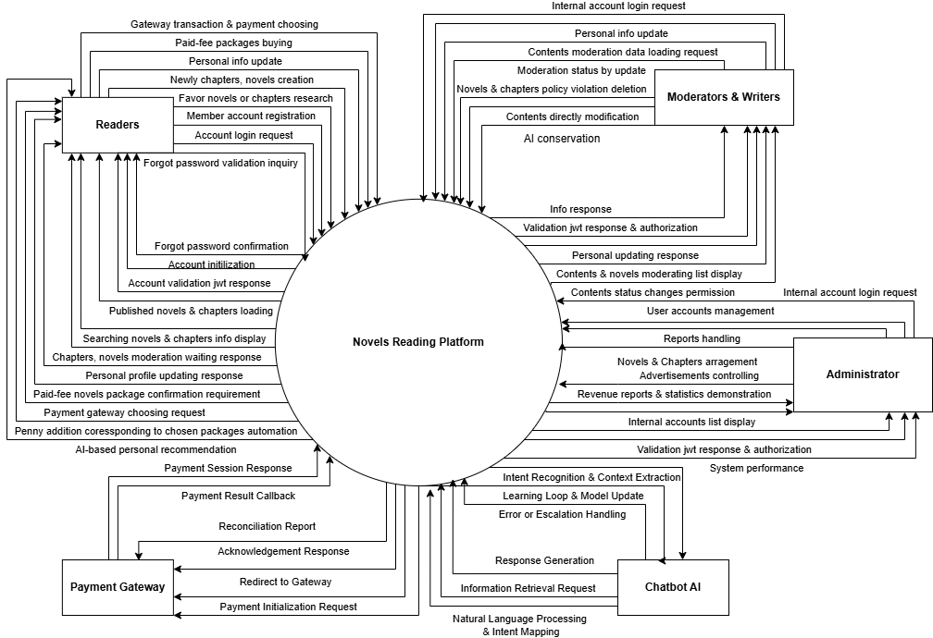
Context Diagram of Novels Reading Plaform

III.2 System User Profile
No. | User Role | Description / Responsibilities | Access Level / Permissions | Key Interactions / Modules
1 | Guest Reader | Browse public novels, chapters without being needed to register, view underlying samples, search limited catalogue, feedbacks. | Anonymous access  ( Read – only ) | Public catalog, Search, Recommendation Preview, Contribution
2 | Reader | Register/login, chat with inner AI, read the full chapters ( free/purchased), filter by enhanced selection, choose paid-fee packages, payment,  create newly novels & chapters, feedbacks. | Purchase, Search by chatbot & personalization rights | Profile, AI-based personal recommendations, checkout, payment, unlimited purchases
3 | Partner/  Publisher | Create, edit novels, chapters, propose for system moderation, observe the recently uploaded contents, promptly notify the copyrights violation to Administrator | Author account, authoring & moderation privileges, policy violations  Publication. | Content Management, content access, novels & chapters post, contents moderation, violation report.
4 | Moderator/ Content Reviewer | Uploaded contents management ( involve novels, chapters & translated novels translated novels submitted by authors or partners), update profile, handle reports, manage publishers and sign licensing agreements. | Inner account, publisher and reader level controlling, determine contents strictly | Partner contract management, uploaded contents management on community, issues resolvement.
5 | System Administrator | Manage users, roles, platform configuration, view system logs, run reports, perform emergency actions. | Fullly covered system access | Admin console, system settings, logs, payment transactions report
6 | IT Business Analyst | Define requirements, review reports, design conceptual wireframe, physical ERD drawing, accept features/UAT | Access to requirement docs, acceptance features, analytics. | Requirement management, UAT, dashboard analytics, ERD in physical model
7 | Development Team | Understand the proposed requirements, define software architecture & technologies used within the system, get in touch with IT Business Analyst for clear validation. | Principal development  in the system. | System development, maintenance,  unit testing & deployment.

- FUTURE BUSINESS PROCESS

IV.1 List of Future Business Process
List of Future Business Processes for Novels Reading Platform
No. | Process ID | Business Process Title | Description | Primary Actor (s) | Expected Outcome
1 | BP-001 | User Registration  & Login | Users could register, verify account by email and access to the system securely & adaptly. | Guest Reader, Unregistered User | User logs successfully into the system
2 | BP-002 | Browse & Search | Users browse and search novels by category, keyword, or recommendation. | Guest Reader, Unregistered User, Partner, Publisher | Search results displayed with metadata.
3 | BP-003 | Reading & Contribution | Users read the unpaid-fee chapters, novels, leave feedbacks and contribute to ideas box for experience or further demands. | Guest Reader, Unregistered User | Reading experience occurs smoothly without getting interruption.
4 | BP-004 | Written  novels & chapters creation and submission. | Users easily post the novels published by themselves. | Unregistered User, Partner, Publisher | Submission successfully sent to moderation team.
5 | BP-005 | Subscription & Purchase Management | Users confirm subscription relevant to paid-fee item. | Unregistered User, Partner, Publisher | Subscription confirmed.
6 | BP-006 | Payment Gateway & Transaction Control | Users choose a preferred payment gateway, complete payments, and view transaction history. | Unregistered User, Partner, Publisher | Payment transaction completed successfully.
7 | BP-007 | Contents publishment & approval | The inner moderation team strictly observes upload contents, approves or rejects the violation items | Moderators crew, Partner, Publisher | Moderation results updated, approved content published to the community.
8 | BP-008 | System Maintenance Reporting | Admin performs maintenance reports. | Administrator | System operates stably, reports generated.
9 | BP-009 | Internal Account Management | Admin manages the existing account within the system | Administrator | Inner accounts could be controlled comprehensively.
10 | BP-010 | Performance Monitoring & Dashboard Analytics. | Administrator views statistical reports via the dashboard for decision-making and performance monitoring. | Administrator | Operational insights and visual reports successfuly generated.

IV.2 Use Case Diagram (Overview)

IV.2.1 Purpose
This section is going to offer the panaramic overview of “Inkrealm” principal functionalities and how each category of user socializes with them. The diagram illustrates the relationships between actors (end users and system roles) and the primary use cases of the platform.

IV.2.2 Actors Identified
Actor | Description
Unregistered User | A guest who can browse, search, and read limited content without registration
Reader | A registered member who can log in, read full content, manage their profile, post novels, interact with AI chatbot and purchase paid-fee subscriptions for opening innovative features
Moderator/Publisher | Inner members that these of whom take ownership to review and moderate the posted novels & chapters strictly, handle violation reports in advance of publishing to the community.
Administrator | A member who could supervise the existing inner accounts comprehensively, view the statistics dashboard for decision-making promtly.
Payment Gateway | The external system which plays a virtual role in resolving the payment inquiries from the users’ side within the system.
Chatbot AI | An inner actor which shall be trained insightly by the high-experienced development team with a view to resolving the users’ issue.

IV.2.3 Overview
The following diagram illustrates the general interactions between users and the “Inkrealm” platform. It encompasses major functional areas such as account management, browsing and reading, novel posting, AI chatbot interaction, moderation, and supervision.
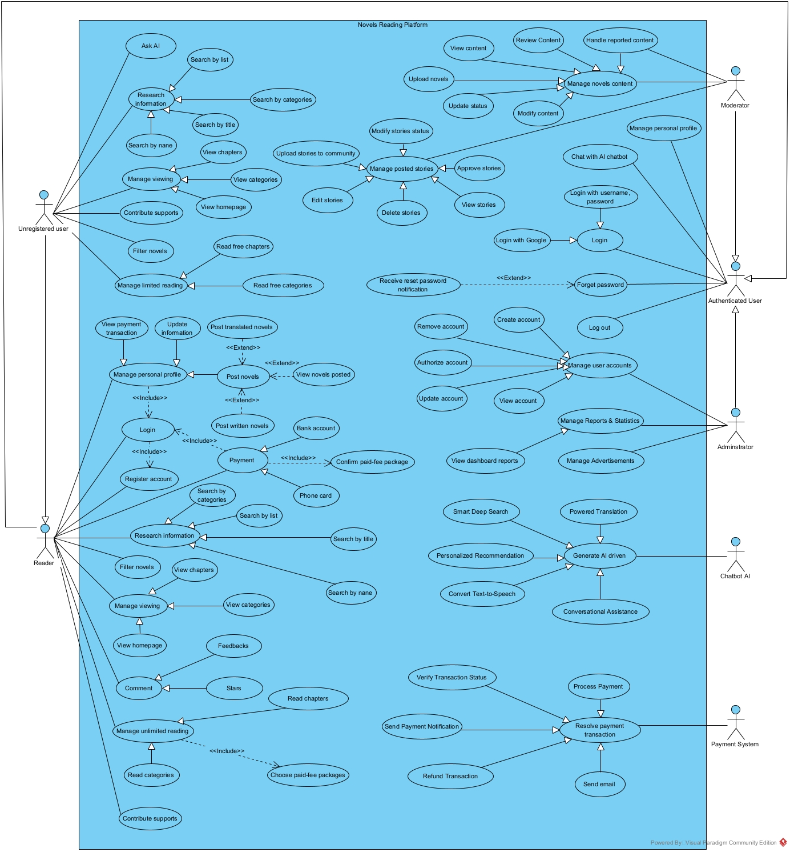

IV.2.4 Use Case Grouping

Business Process ID | Use Cases Represented | Primary Actor(s) | Purpose
BP-001  User Registration & Login | UC-01 Register Account  UC-02 Login  UC-16 Verify Email  UC-17 Resend Verification Email | Reader, Unegistered User | Users could register, verify account by email and access to the system securely & adaptly.
BP-002  Browse & Search | UC-03 Browse Content, UC-04 Search by categories | Reader, Unregistered User, Partner, Publisher | Users browse and search novels by category, keyword, or recommendation.
BP-003  Reading & Feedbacks | UC-05 Read Novel,  UC-06 Comment | Reader, Unregistered User | Users read the unpaid-fee chapters, novels, leave feedbacks and contribute to ideas box for experience or further demands.
BP-004  Novel & Chapter Submission | UC-07 Post novels | Unregistered User, Partner, Publisher | Users easily post the novels published by themselves.
BP-005  Subscription & Purchase | UC-08 Confirm paid-fee package | Unregistered User, Partner, Publisher | Users confirm subscription relevant to paid-fee item.
BP-006  Payment Gateway | UC-09 Process Payment, UC-10 View Transaction History | Unregistered User, Partner, Publisher | Users choose a preferred payment gateway, complete payments, and view transaction history.
BP-007  Content Moderation | UC-11 Review Content,  UC-12 Update Status | Moderators crew, Partner, Publisher | The inner moderation team strictly observes upload contents, approves or rejects the violation items
BP-008  System Maintenance | UC-13 Manage Reports & Statistics | Administrator | Admin performs maintenance reports.
BP-009  Account Management | UC-14  Manage user accounts | Administrator | Admin manages the existing account within the system
BP-010  Performance Monitoring | UC-15  View dashboard reports | Administrator | Administrator views statistical reports via the dashboard for decision-making and performance monitoring.

IV.3 High-Level Process Flow

IV.3.1 Purpose
The purpose of the High-Level Swimlane Diagram is to illustrate the end-to-end business workflows of the “Inkrealm” Novels Reading Platform across key user roles and system components.
This diagram provides a consolidated business-oriented view that clarifies:
- The interaction flows between users and the system.
- The division of responsibilities among different user roles (Readers, Publishers, Moderators, Administrators).
- The major business processes executed without going into system-level technical details.
- How external systems (e.g., Payment Gateway) participate within the platform’s workflow.
- The overall operational sequence that supports the system’s functional scope.
This high-level view allows business stakeholders to clearly understand how the platform operates from a process perspective before progressing into detailed BPMN modeling or technical system design.

IV.3.2 Actors / Lanes
The following actors represent the primary lanes used in the High-Level Swimlane Diagram. Each lane corresponds to a particular role or system participating in the business processes:
No. | Actor / Lane | Description / Responsibilities
1 | Unregistered User | A non-authenticated user who can browse the public catalog, view limited chapter previews, search basic content, and interact with the platform at a restricted level prior to registration.
2 | Reader  (Registered User) | Authenticated user with complete access to reading full chapters, managing profile settings, interacting with AI recommendation, purchasing subscription packages, and engaging with the platform’s features.
3 | Moderator (Including Publisher/Writer Partners) | Internal reviewer and external writing partners responsible for content creation, submission, quality validation, copyright compliance checking, and approval/rejection of novels and chapters.
4 | Administrator | Oversees system configuration, user management, maintenance operations, reporting, analytics, and overall platform governance.
5 | Payment Gateway (External System) | Third-party financial service responsible for processing subscription payments, validating transactions, and returning confirmation status to the Inkrealm system
6 | AI Chatbot (External/Service Component) | Conversational AI service that handles user Q&A, provides personalized recommendations, assists navigation, and escalates complex queries to human support when required.

IV.3.3 Swimlane Diagram
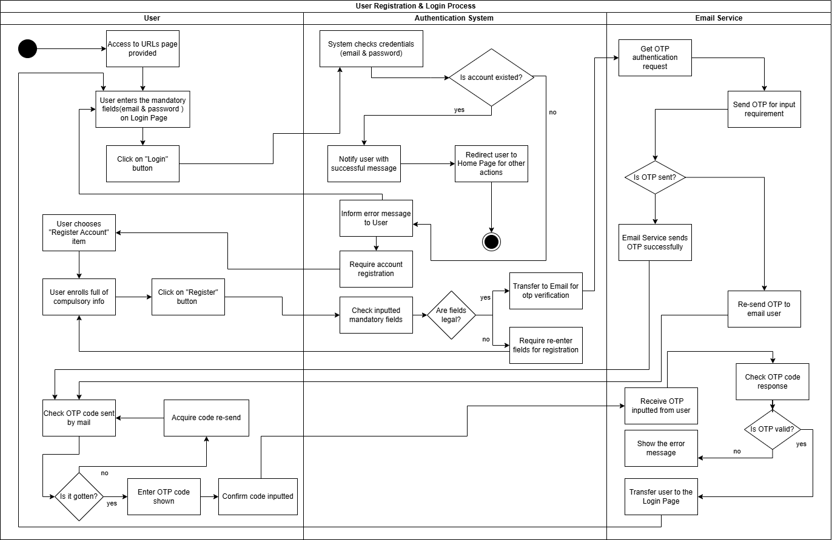
User Registration & Login
Business Processes Covered: BP-001
Actors Involved: User ( Unregistered Guest, Reader ),
Authentication System, Email Service
Purpose: Users could register, verify account by email and access to the system securely & adaptly.

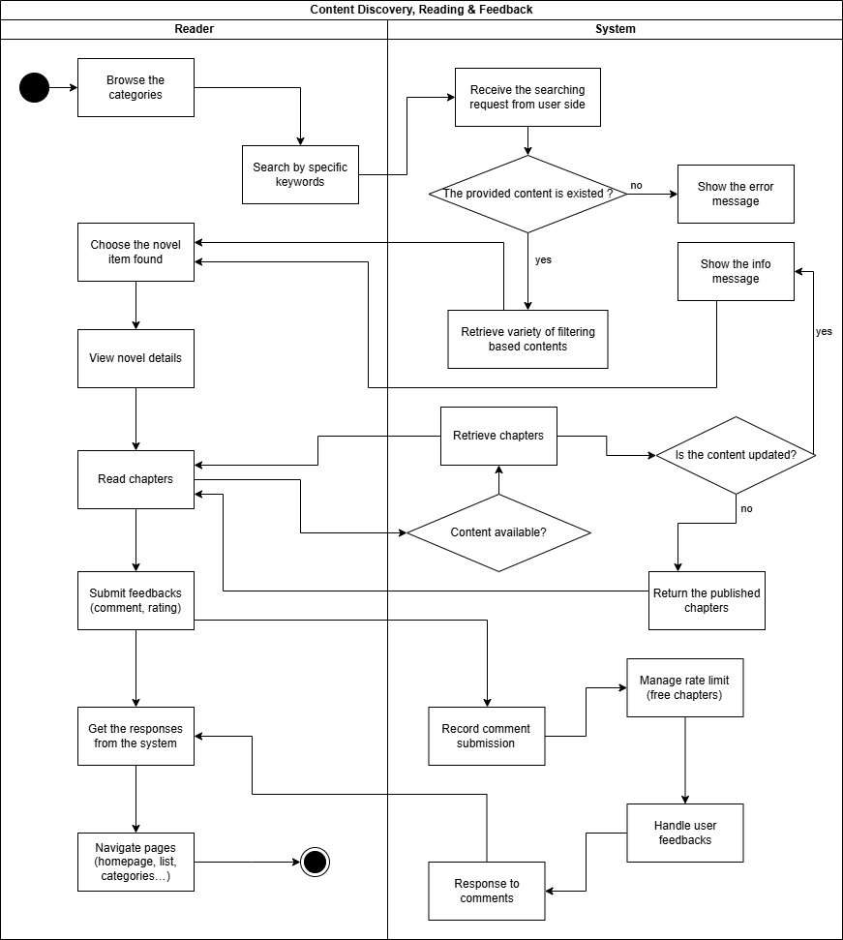
Content Discovery, Reading & Feedbacks
Business Processes Covered: BP-002, BP-003
Actors Involved: User ( Unregistered Guest, Reader ), System
Purpose: Users read, search, browse the unpaid-fee chapters, novels, leave feedbacks and for experience or further demands.
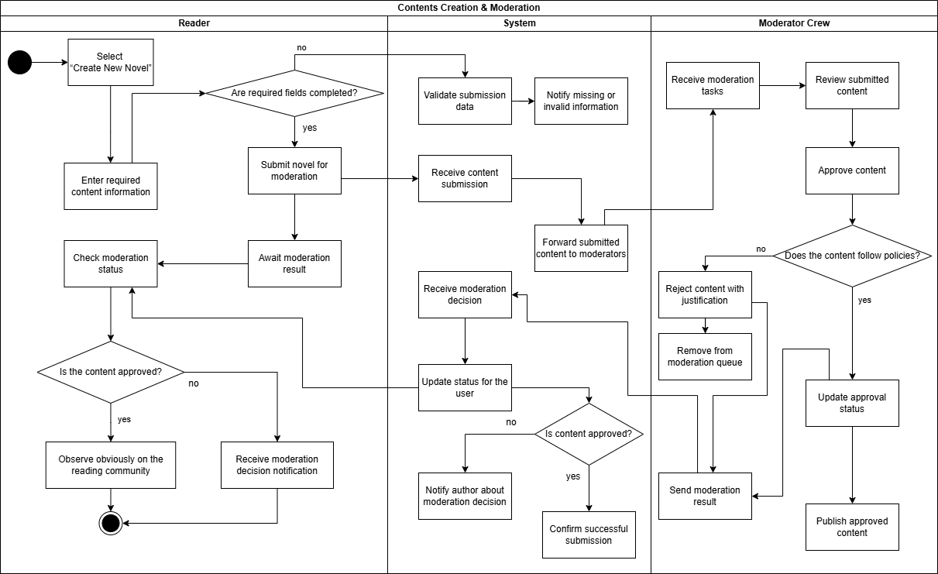
Contents Creation & Moderation
Business Processes Covered: BP-004, BP-007
Actors Involved: User ( Unregistered Guest, Reader ), System, Moderator Crew
Purpose: Users easily post the novels published by themselves. The inner moderation team strictly observes upload contents, approves or rejects the violation items.

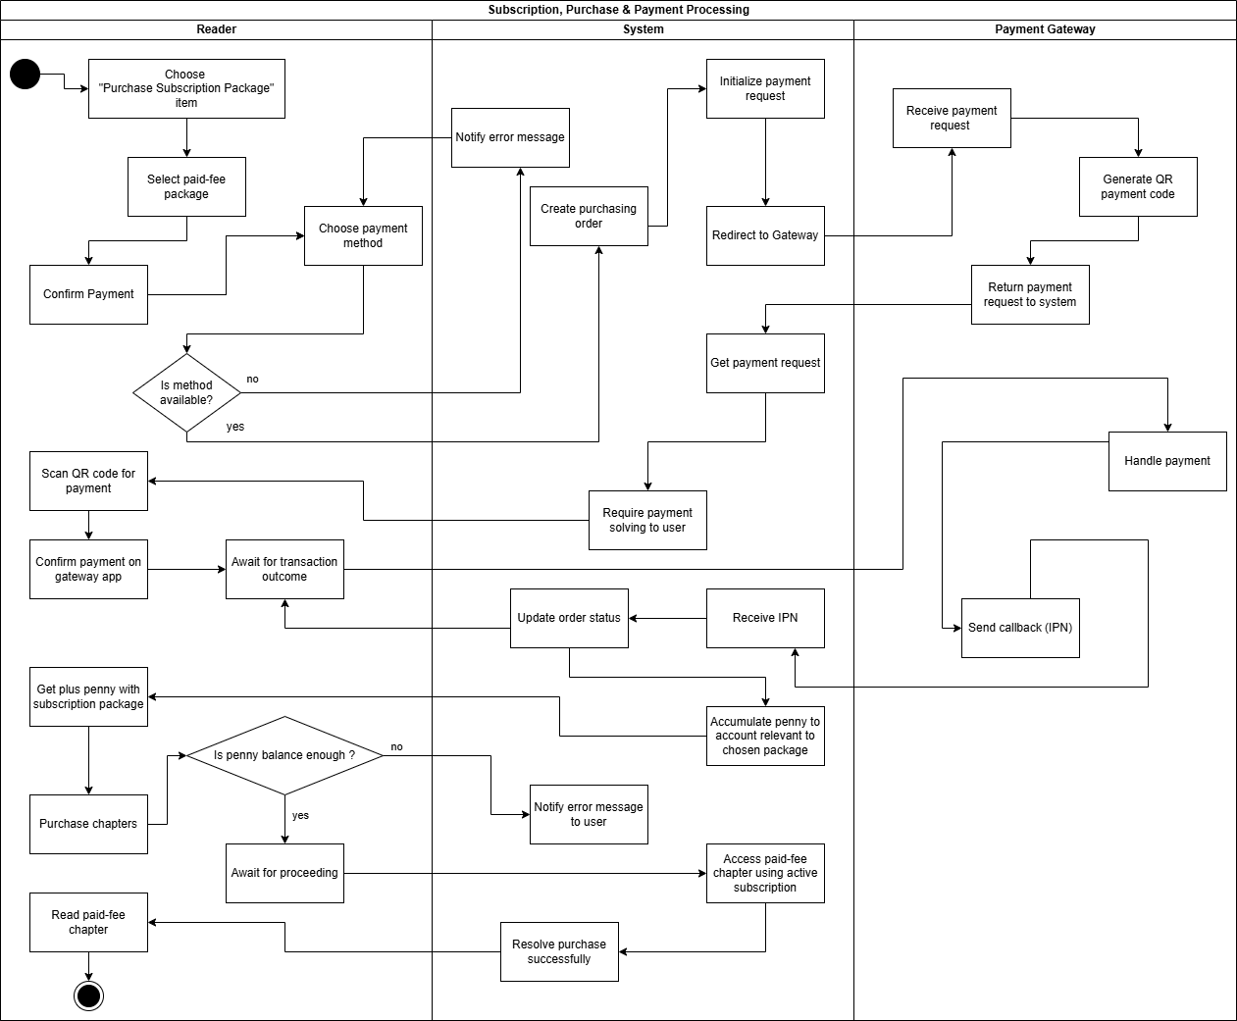
Subscription, Purchase & Payment Processing
Business Processes Covered: BP-005, BP-006
Actors Involved: Reader, System, Payment Gateway
Purpose: Users confirm subscription relevant to paid-fee item and choose a preferred payment gateway, complete payment.
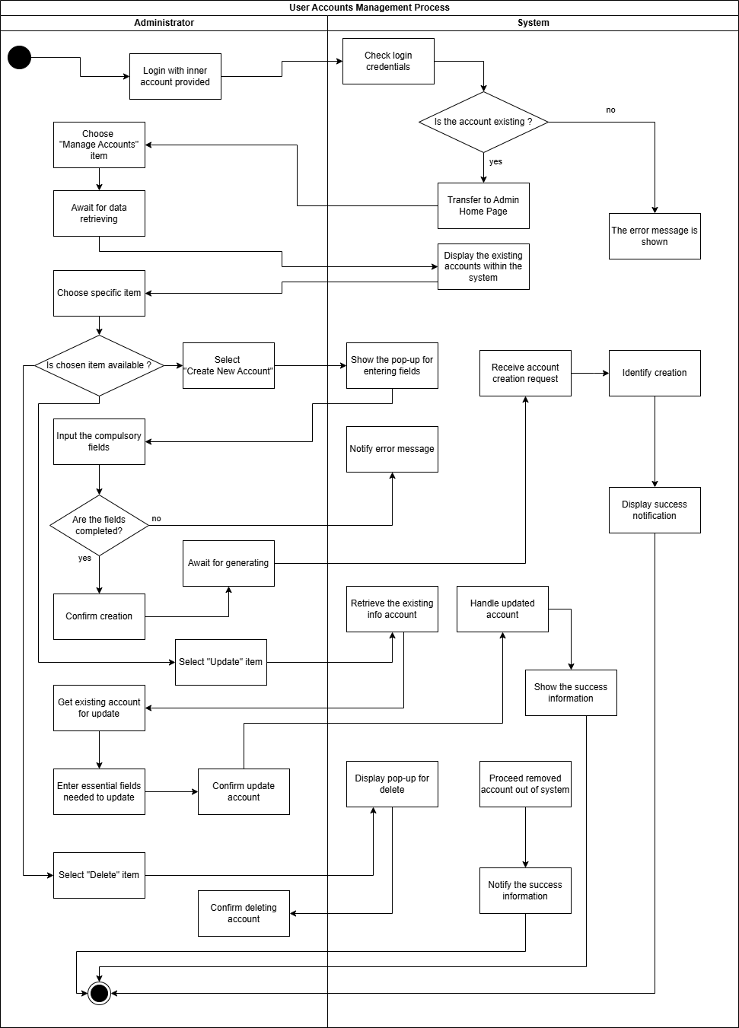
User Accounts Management Processing
Business Processes Covered: BP-009
Actors Involved: Administrator, System
Purpose: Admin manages the existing inner account within the system.

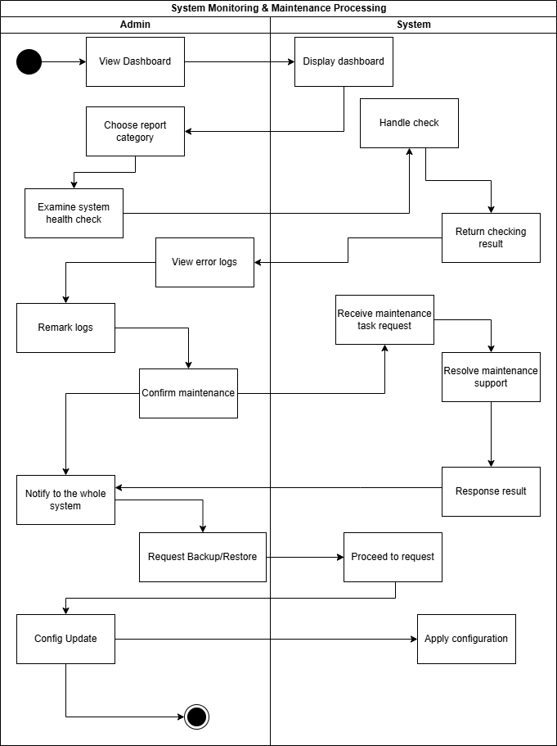
System Monitoring & Maintenance Processing
Business Processes Covered: BP-008, BP-010
Actors Involved: Administrator, System
Purpose: Administrator views statistical reports via the dashboard for decision-making and performance monitoring.

IV.4 Detailed BPMN Diagram
This section provides detailed Business Process Model and Notation (BPMN) diagrams for all critical business processes of the system. Each BPMN illustrates the interaction among system components, external services, and end users, ensuring a clear and unambiguous understanding of process flows, decision logic, and exception handling mechanisms.
For every BPMN diagram, the following information is presented:
- Purpose – Explains why the process exists.
- Scope – Defines what is included and excluded.
- Actors / Pools / Lanes – Identifies which stakeholders or systems participate in the process.
- Main Flow Summary – Describes the expected flow under normal conditions.
- Exception Flow Summary – Describes how the system responds to errors or unusual conditions.
- Business Rules – Lists constraints, validations, or special conditions applied.
- References – Links to Use Cases or Requirements that this BPMN supports.

IV.4.1 BPMN – Login & Registration Process
Purpose
This process describes how users access the system through login or account registration. It outlines how the system validates login credentials, processes new registration requests, manages OTP sending and verification through the Email Service Provider, handles database insertion for new accounts, and completes authentication by generating a JWT access token.
Scope
Includes accessing the system, choosing authentication paths, submitting credentials or registration data, receiving and validating OTP codes, creating new accounts in the database, issuing JWT tokens, and redirecting users after successful login.
Actors / Pools / Lanes
User – Accesses the system, performs login or registration, enters credentials or OTP, and completes authentication.
System – Handles access requests, validates credentials, processes registration data, manages OTP verification, creates user accounts, issues JWT tokens, and redirects users after successful actions.
Email Service Provider – Generates and sends OTP codes, processes OTP resend requests, and supports OTP validation with the system.

Main Flow Summary
1. Accessing the System
- The User accesses the system via published URLs.
- The System handles the incoming access request.
- The User selects either the Login or Register option.
2. Login Process
- The User clicks the Login button.
- The User enters mandatory login information (e.g., username, password).
- The System validates the login information.

If the account exists and data is valid:
- The System notifies the User of successful login.
- The System returns a JWT token to the User.
- The System redirects the User to the homepage or other authorized pages.
If the account does not exist or credentials are invalid:
- The System shows a rejection message.
- The User may retry login or proceed to registration.

3. Registration Process
Registration Form
- The User selects Register.
- The User enters all required registration fields in the registration form.
- The User submits the registration form.
- The System validates the input data.
If data is invalid:
- The System requests re-registration, and the User must re-enter the form.
If data is valid:
- The System forwards an OTP request to the Email Service Provider.

4. OTP Generation & Delivery
- The Email Service Provider receives the OTP request.
- The Provider sends the OTP code to the User's email.
OTP Delay Handling
- If the User does not receive the OTP within 10 minutes, they may request OTP re-sending.
- The Email Provider processes the resend request and generates a new OTP.

5. OTP Verification
- The User enters the received OTP code into the system.
- The System checks the OTP validity using Email Provider confirmation.
If the OTP is incorrect or expired:
- The System rejects the code.
- The User must re-enter the code or request another resend from the Email Provider.
If the OTP is valid:
- The Email Provider confirms the valid OTP.
- The System approves the registration and proceeds with account creation.

6. Account Creation & Completion
- The System examines the registration data again and checks database insertion.
- If valid, the System inserts the new account into the database.
- The System notifies the User that registration is successful.
- The System transfers the User to the Login page.
- The User may now log in using their new credentials.

Exception Flow Summary
Login Exceptions
- Invalid credentials
System shows a rejection message → User retries login.
- Account not found
User is prompted to register instead.
Registration Exceptions
- Invalid registration fields (missing, format errors, invalid email)
System requests re-submission.
- OTP not received within time limit
User requests OTP resend.
- OTP invalid or expired
User must re-enter or request a new code.
- Database insertion failure
System cannot create the account → User must restart the registration process.

Email Service Provider Exceptions
- OTP delivery delay
Provider sends a new OTP after 5 minutes.
- Incorrect OTP entered by User
Provider rejects validation; User must retry.

Business Rules
- OTP codes are valid for 10 minutes.
- Users may request OTP resending but only within allowed retry limits.
- Email must be unique and not already associated with an account.
- Password must follow platform security rules (length, complexity, prohibited patterns).
- All mandatory registration fields must be provided before submission.
- JWT tokens must be generated only after successful login validation.
- Database insertion must succeed before the system confirms registration.
- Login attempts with invalid credentials must not return detailed error information (security rule).

References
- Use Case: UC-01 Register Account, UC-02 Login
- Requirements: FR-01, FR-02, FR-04, NFR-02, NFR-06

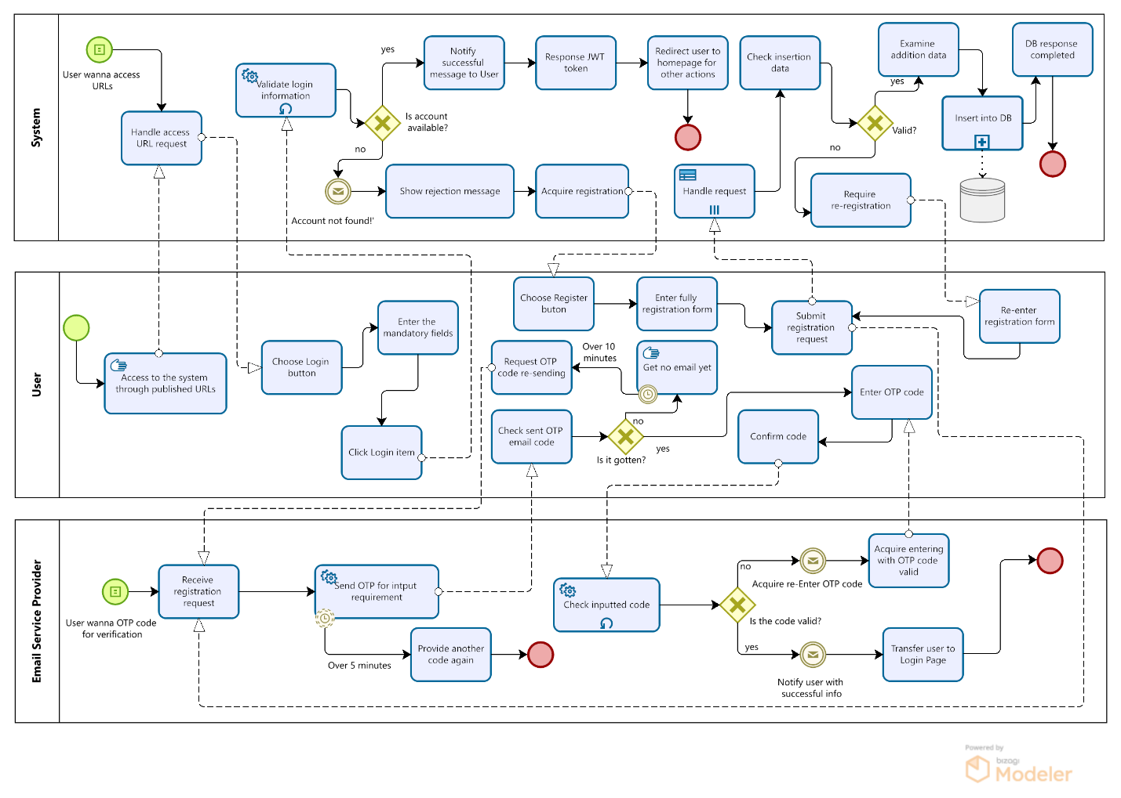

IV.4.2 BPMN – Content Discovery, Reading & Feedbacks Process
Purpose:
This process describes how users browse categories, search content by keywords, view detailed novel information, read chapters, and submit feedback (e.g., comments, ratings). It also outlines how the system processes search queries, handles database retrieval, manages rate limits for free chapters, logs feedback submissions, and handles user comments.
Scope:
Includes content discovery via browsing or keyword search, data retrieval from the database, result presentation, navigation to novel details, reading chapters, and submitting comments or ratings.
Actors / Pools / Lanes:
- User – Initiates browsing or searching, views content results, reads chapters, and submits feedback.
- System – Processes search requests, retrieves data from the database, handles paging and filtering, processes reading requests, manages rate limits for non-subscribed users, and stores user feedback.

Main Flow Summary
1. Content Discovery
- User browses categories or inputs specific search keywords.
- User clicks the Search button to initiate the search.
- System receives the search request and retrieves data from the database based on the input conditions.
- System checks database response availability.
  - If results exist → Proceed to “Transfer list data found”.
  - If no results → System returns an error message to the User.
- System transfers found data and responds results to the User.
- User views the list of matched contents.

2. Novel Selection & Reading
- User selects a specific novel from the search results.
- System returns detailed data for the selected novel.
- User chooses to read chapters.
- System fetches data by novel ID, manages rate limits for free chapters, and returns content pages.
3. Submitting Comments / Ratings
- User inputs feedback (e.g., comment text, rating value).
- System records comment submission.
- System retrieves and returns the updated feedback list.
- User views updated feedback and returns to other pages.

Exception Flow Summary
Search Exceptions
- No search results:
System returns error → User retries with different keywords.
- Database response failure:
System returns DB error → User must try again later.

Novel Detail / Reading Exceptions
- Chapter access beyond rate-limit for free users:
System restricts viewing and may prompt subscription.
- Invalid novel ID or deleted novel:
System returns “Content no longer available” message.
Feedback Exceptions
- Invalid comment content (empty, profanity, too long):
System rejects submission and returns validation message.
- Network error during submission:
User is informed and may retry.
Business Rules
- Search supports multiple fields: name, published year, createdDate, chapter count, etc.
- Feedback content length must comply with system constraints.
- Rate limit rules for non-subscribed users (e.g., certain free chapters allowed per day).
- Comments must be associated with authenticated user accounts.
- Novel data must be active and visible; hidden or flagged novels are excluded.
References
- Use Case: UC-03 Browse Content, UC-04 Search by categories, UC-05 Read Novel,
UC-06 Comment
- Requirements: FR-10, FR-11, FR-12, FR-15, NFR-03, NFR-04

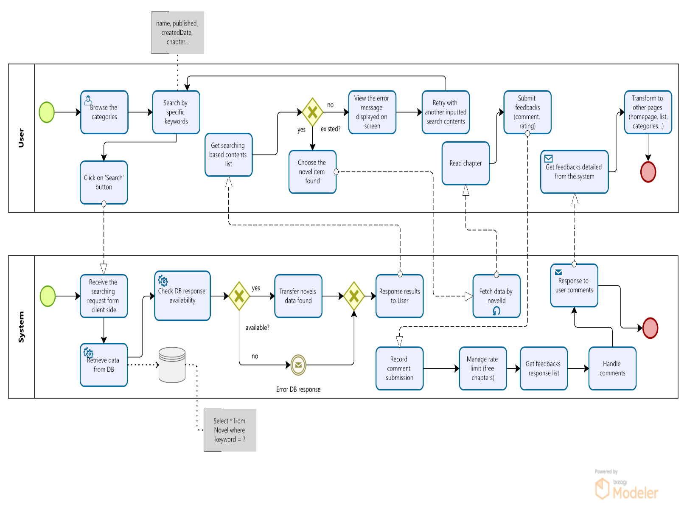

IV.4.3 BPMN – Contents Creation & Moderation Process
Purpose
This process defines how a user creates new content (e.g., a new novel or chapter), how the system validates and forwards it for moderation, how moderators review and approve or reject the submission, how the system publishes approved content, and how notifications are sent back to the user.s
Scope
Includes content submission, system validation, routing to moderators, moderation review and decision-making, database status updates, publication of approved content, delivery of user notifications, and all related exception paths (validation issues, system or database errors, moderation delays, and email failures).
Actors / Pools / Lanes
User – Creates content, submits it for review, responds to email notifications, and views content once approved.
System – Validates submissions, forwards content to moderators, updates moderation status, publishes approved content, sends notifications, and handles system or database errors.
Moderator – Reviews submitted content, checks compliance, approves or rejects items, and escalates cases when necessary.

Main Flow Summary
1. User Submission
- The User selects “Create New Novel” from the interface.
- The User enters all mandatory content information (e.g., title, synopsis, tags, chapters).
- The User clicks the Publish/Submit button.
- The User enters a waiting state (“await 3 days” as shown in BPMN).
- The System sends an initial submission response email confirming receipt of the content.

2. System Pre-Validation
- The System retrieves the submitted data: Get submission data.
- The System checks for missing or invalid information.
  - If invalid → The system returns an error message “Content is not available”, and the flow ends.
  - If valid → Continue to Step 8.
- The System forwards the submitted content to the Moderator for review.

3. Moderator Review & Decision
- The Moderator receives the moderation task.
- The Moderator selects the submitted content for review.
- The Moderator enters the supervision stage: Supervise content.
- The Moderator reviews the chapter(s):
  - If the content is not legal or violates rules → proceed to rejection path.
  - If the content is acceptable → proceed with approval.
- If rejecting:
  - Moderator chooses status = “Rejected”.
  - Moderator submits the moderation decision to the system.
- If approving:
  - Moderator updates the content status as Approved.
  - Moderator sends the moderation result back to the System.

4. System Processing of Moderation Outcome
- The System receives the moderation response and begins: Resolve moderating status.
- The System updates the moderation status by chapterId in the database.
- The System then checks the moderation status request:
  - If approved → continue to publishing.
  - If rejected → prepare denied message for the user.
- If an error occurs while checking/updating status (e.g., database failure):
  - The System logs the error.
  - The System notifies the IT Administrator.
  - The process stops at the error point.

5. Publishing & User Notification
If Approved
- The System publishes the content on the reading community platform.
- The System sends a notification email to the user stating the content is approved and published.
- If the email is successfully sent → process ends.
- If the email fails → the System records Sent Failed, and the flow ends.
If Rejected
- The System displays a Denied message for the User.
- The System sends a rejection email (with or without reasoning depending on design).
- As above, the email can be marked Sent Successfully or Sent Failed.

Exception Flow Summary
No email received after 3 days
- The User is expected to contact Customer Service for assistance.
System Exceptions
Invalid or missing content information
- System returns: “Content is not available”.
- User must correct the submission and retry.

Database connection lost
- System logs a system error.
- System notifies the IT Admin.
- Moderation status update fails.
Email delivery failure
- System marks notification as Sent Failed.
- User does not receive approval/rejection email.
Moderator Exceptions
- Moderation takes too long (exceeds 2 days)
- System escalates the task automatically to an Advanced Moderator.
- Illegal or violating content
- Moderator marks content as Rejected.
- Flow returns to System rejection-handling.

Business Rules
- Mandatory fields must be completed before the system accepts the submission.
- Only Approved content can be published to the reading community.
- Content legality must follow:
- Platform policy.
- Copyright rules.
- Local law compliance.
- No explicit/illegal material outside permitted scope.
- Rejected content must include a reason (if configured).
- All moderation decisions must be stored with:
- Timestamp
- Moderator ID
- Moderation result (Approved/Rejected)
- Email notifications must record:
- Sent status
- Failure reasons (if available)
- Escalation triggers after 2 days of no moderator action.
- Content cannot be published if:
  - Database cannot be updated.
  - Moderation status is missing or corrupted.
  - Novel or chapters are flagged or hidden in the system.
References
- Use Case: UC-05 Read Novel, UC-06 Comment, UC-07 Post novels, UC-11 Review Content, UC-12 Update status
- Requirements: FR-01, FR-02, FR-04, NFR-02, NFR-06

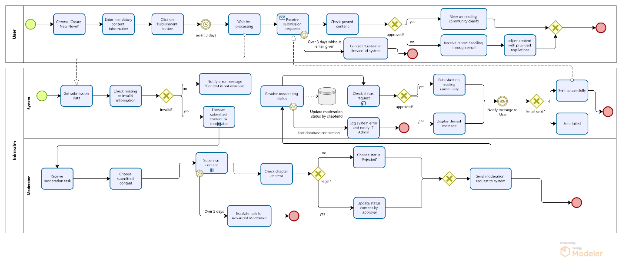

IV.4.4 BPMN – Subscription, Purchasing & Payment Process
Purpose
This process describes how users purchase subscription packages or pay-per-chapter content using available payment methods. It covers user selection of packages, payment method confirmation, system order creation, communication with the payment gateway, IPN/callback handling, updating balance or chapter access rights, and delivering final responses to the user.
Scope
Includes selecting subscription or chapter purchase packages, initializing payment requests, processing payment callbacks, updating order status, adding bonus coins or balance, activating paid chapters, and returning system responses for successful or failed transactions.
Actors / Pools / Lanes
User – Selects subscription or chapter packages, chooses a payment method, confirms payment, checks transaction status, and consumes purchased content.
System – Validates payment methods, creates purchasing orders, initializes payment requests, processes gateway callbacks/IPN, updates order status, manages account balances, and activates paid chapters.
Payment Gateway – Generates payment codes (e.g., QR), processes payments, returns transaction status, and sends callbacks/IPN to the system.

Main Flow Summary
1. Package Selection & Payment Initialization
- User initiates a purchase (subscription package or chapter purchase).
- User selects the desired package.
- User chooses a supported payment method.
- System validates the payment method.
• If invalid → System notifies the User and terminates the flow.
- System creates a purchasing order.
- System initializes a payment request and forwards it to the Payment Gateway.

2. Payment Processing
- Payment Gateway receives the payment initialization request.
- Payment Gateway generates a payment code (e.g., QR code).
- Payment Gateway returns the payment information to the System.
- System forwards the payment code/details to the User.
- User completes payment using the Payment Gateway's application or interface.
- Payment Gateway processes the payment.
3. Callback / IPN Handling
- Payment Gateway sends a callback (IPN) to the System with the payment result.
- System receives and validates the IPN response.
- System updates the order status:
• If payment is successful → mark as Successfully Paid.
• If payment fails → mark as Failed.
- System updates the user’s balance or subscription:
• Subscription → update subscription status.
• Top-up → accumulate bonus coins to the account balance.
• Chapter purchase → activate chapter access.
- System returns the result to the User.
4. Post-Payment Actions
- User checks payment status on the system.
- If successful → User views updated balance / unlocked chapters.
- User proceeds to read purchased chapters.

Exception Flow Summary

Payment Exceptions
- Unsupported payment method
System rejects the request and notifies the User.
- Payment exceeds time limit (e.g., 30 minutes)
Payment Gateway terminates the transaction → System updates order as Failed.
- Callback/IPN failure or timeout
System marks order as Failed → User must retry the purchase.
- Payment Gateway service error
System returns a failure response → User is informed to try again later.
Balance & Chapter Exceptions
- Balance not enough for chapter purchase
System rejects and notifies User to top up.
- Order updated but bonus coins not applied
System returns an error state → User must retry or contact support.
System Exceptions
- Database write failure
System returns DB error → User must retry the payment.
- Unexpected system error
System stops the flow and returns a general failure response.
Business Rules
- Payment methods must be pre-configured and validated by the system.
- Orders must be created before any payment request is sent to the payment gateway.
- Callback/IPN must be authenticated before updating order status.
- Successful payments must trigger:
1. subscription activation
2. penny accumulation
3. Paid-fee chapter unlocking
- Failed payments must never modify user balance or chapter access.
- Users must be able to re-check payment status from their transaction history.
- Expired or invalid QR/payment codes are automatically rejected.
References
- Use Case: UC-08 Confirm paid-fee package, UC-09 Process Payment, UC-10 View Transaction History
- Requirements: FR-20, FR-21, FR-22, FR-25, FR-28, NFR-06, NFR-07
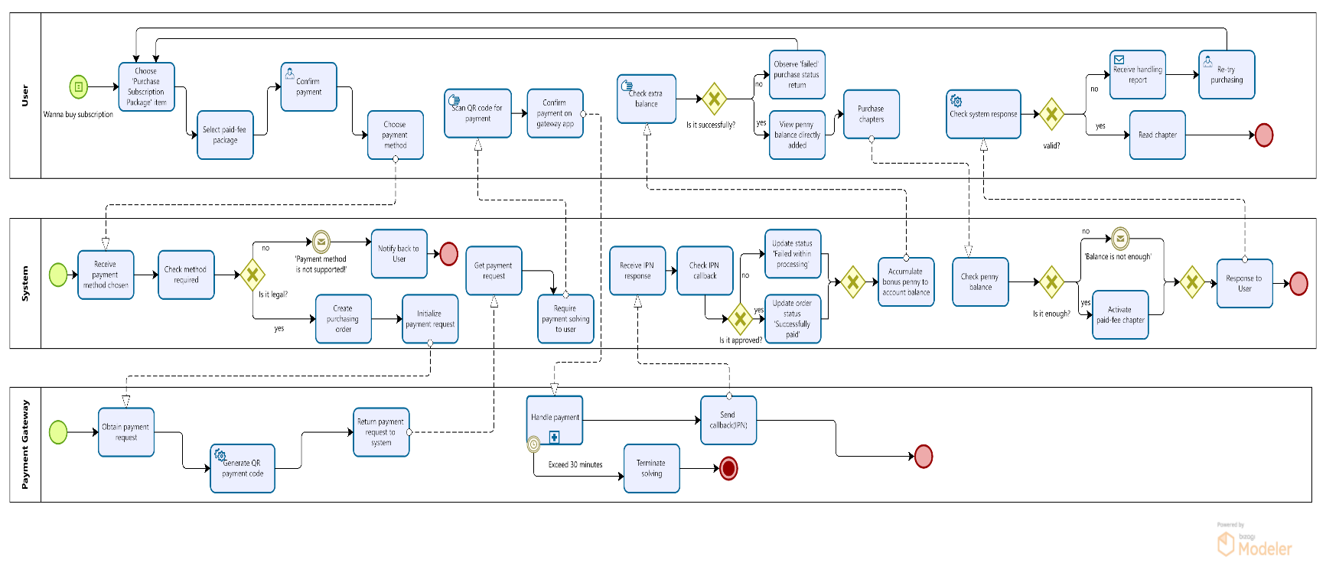

V. FUNCTIONAL REQUIREMENTS
This section defines the functional capabilities that the system must provide in order to fulfill the business objectives and support the workflows described in the preceding Business Processes and Use Case Grouping. The requirements outlined here specify the essential behaviors, interactions, and system responses necessary to ensure that all functionalities operate consistently, reliably, and in alignment with user and stakeholder needs.

V.1 List of Functional Requirements
ID | Module | Feature Name | Description | Priority | Related Use Case
FR-001 | User Registration & Login | Register Account | The system shall allow users to create a new account by entering required information. | M | UC-01
FR-002 | User Registration & Login | Login | The system shall authenticate users using username and password. | M | UC-02
FR-003 | User Registration & Login | Email Verification | The email provider service shall send a verification email. | M | UC-16
FR-004 | User Registration & Login | Resend Verification Email | The system shall allow users to request another verification email if needed. | S | UC-17
FR-005 | Browse & Search | Browse & Search Content | The system shall enable users to browse novels by category, ranking, trending list, or recommendation | M | UC-03, UC-04
FR-006 | Reading & Feedback | Read Novel & Comment | The system shall allow users to view accessible chapters and read unpaid-fee content. | S | UC-05, UC-06
FR-007 | Novel & Chapter Submission | Post Novel / Chapter | The system shall allow users to upload their own novel content, including metadata and chapters. | M | UC-07
FR-008 | Subscription & Purchase | Confirm Paid-Fee Package | The system shall allow users to select and confirm a subscription or fee-based package. | M | UC-08
FR-009 | Payment Gateway | Process Payment | The system shall integrate with external payment gateways to support transactions. | M | UC-09
FR-010 | Payment Gateway | View Transaction History | The system shall display a record of previous transactions linked to the user's account. | C | UC-10
FR-011 | Content Moderation | Review Content | Moderators shall be able to review newly submitted novels/chapters and classify them as approved or rejected. | M | UC-11
FR-012 | Content Moderation | Update Status | The system shall update moderation results in the database and notify the content owner. | M | UC-12
FR-013 | System Maintenance | Manage Reports & Statistics | The system shall provide administrative access to generate, view, and export system reports. | S | UC-13
FR-014 | Account Management | Manage User Accounts | Administrators shall be able to update roles, deactivate accounts, or reset credentials. | M | UC-14
FR-015 | Performance Monitoring | View Dashboard Reports | The system shall provide dashboard visualizations of content activity, usage, revenue, and system performance. | M | UC-15

V.2 Detailed Functional Requirement Specifications

Item | Description
Requirement ID | FR-001
Requirement Title | Register Account
Priority | Must
Functional Requirement Description | The system shall allow a new user to register an account by providing mandatory information – including username, fullname, email address, and password. The system shall validate the input format, check for duplicated email/username and trigger an email for activating verification workflow.
Frequency of Use | High
Acceptance Criteria | 1. All obligatory fields must be entered and determined for validation in advance of creating new user account.  2. The system must check sequentially and reject already-registered email or username.  3. Encryption and securely store must be compulsory with the user password.  4. User account should be created in “Pending Verification” status by the system.  5. An email notification should be automatically sent within 5 seconds after successful registration.  6. User must receive a confirmation message indicating that verification is required before login.  7. User activates account by clicking on the provided URL path with the gotten email.  8. All failed validations must show particularly descriptive error messages.
Related Business Process | Refer to BP-001

Item | Description
Requirement ID | FR-002
Requirement Title | Login
Priority | Must
Functional Requirement Description | The system shall allow a registered user to log in by submitting mandatory credentials including username and password. The system shall validate input format, verify account activation status, authenticate user credentials, and establish a secure session token upon successful login.
Frequency of Use | High
Acceptance Criteria | 1. All mandatory fields (username, password) must be provided before login.  2. The system must validate correct data format for all inputs.  3. System must check whether the user account is activated before authentication.  4. Incorrect or invalid login attempts must return clear and descriptive error messages.  5. Successful login must be processed within 3 seconds under normal load.  6. System must return explicit error messages when login fails due to unactivated or non-existing accounts.  7. A JWT token must be generated after successful authentication and stored in session with a defined expiry time.  8. After successful login, user must be navigated to the Home Page.  9. System must initialize the user profile using information from the JWT token response.
Related Business Process | Refer to BP-001

Item | Description
Requirement ID | FR-003
Requirement Title | Email Verification
Priority | Must
Functional Requirement Description | The system shall send a verification OTP code email which is intergrated with external email provider to the user’s registered email address after successful account registration. The system shall provide a unique verification URL or code that enables the user to confirm account ownership. Upon accessing the verification link, the system shall validate the token, activate the account if the token is valid, and display a confirmation message to the user.
Frequency of Use | High
Acceptance Criteria | 1. A verification email must be sent immediately after a user completes registration.  2. The verification email must include a unique, time-limited verification link or code.  3. Verification tokens must expire according to system-configured parameters  (e.g., 5 minutes).  4. The system must prevent reuse of expired or previously used verification tokens.  5. When the user accesses a valid verification link, the system must activate the corresponding account and update its status to “Activated”.  6. Invalid, expired, or reused tokens must return appropriate error messages.  7. The system must log all verification attempts for audit purposes.
Related Business Process | Refer to BP-001

Item | Description
Requirement ID | FR-004
Requirement Title | Resend Verification Email
Priority | Must
Functional Requirement Description | The system shall allow a user with an unverified account to request a resend of the verification email. Upon receiving the request, the system shall generate a new verification token, invalidate any previously issued token for the same user, and send a new verification email containing a unique verification link or code. The system shall enforce a predefined cooldown time to prevent excessive resend requests.
Frequency of Use | High
Acceptance Criteria | 1. Only accounts in “Pending Verification” status are eligible to resend verification email.  2. The system must generate a new verification token and invalidate the prior token(s) upon each resend request.  3. The system must send the verification email within 3 seconds after the request.  4. The system must enforce a configurable cooldown time (e.g., 60 seconds) between resent requests.  5. If user attempts to resend within cooldown period, the system must return an explanatory message.  6. Verification tokens must follow the system’s token expiry rules and cannot be reused once expired.  7. All resend attempts (successful or blocked) must be logged for auditing and security monitoring.  8. The system must display confirmation feedback when the resend request is processed successfully.
Related Business Process | Refer to BP-001

Item | Description
Requirement ID | FR-005
Requirement Title | Browse Content
Priority | Could
Functional Requirement Description | The system shall enable users to browse novels by category, ranking, trending list, or recommendation. Users shall be able to search novels by keywords, categories, or authors. Search results should be sortable and filterable according to predefined criteria (e.g., genre, popularity, rating). The system shall support both registered and unregistered users.
Frequency of Use | Medium
Acceptance Criteria | 1. Users can view a list of novels grouped by categories (e.g., romance, fantasy, mystery).  2. Users can sort novels by ranking, trending, or recommendation.  3. Users can search novels by keyword, category, or author name.  4. Search results are displayed with pagination or infinite scroll.  5. System returns relevant results within 2 seconds of search query submission.  6. Users can apply filters (e.g., genre, language, rating) to refine results.  7. Unregistered users can browse content but some restricted features (e.g., saving favorites) require registration.  8. Recommendations are dynamically generated based on user behavior and system algorithm.
Related Business Process | Refer to BP-002

Item | Description
Requirement ID | FR-006
Requirement Title | Read Novel
Priority | Could
Functional Requirement Description | The system shall allow users to view accessible chapters of a novel and read content according to their access rights (free or purchased). Users shall be able to navigate between chapters, bookmark their reading position, and leave feedback such as ratings or comments. The system shall enforce access restrictions for paid content, prompting users to purchase or subscribe if they attempt to access restricted chapters.
Frequency of Use | High
Acceptance Criteria | 1. User can open a novel and view the list of available chapters.  2. Free chapters are accessible directly.  3. Paid chapters prompt the user to purchase or subscribe if they don’t have access.  4. User can read chapter content with proper formatting (text, images).  5. The system navigates to previous/next chapters.  6. Chapter content loads within 2 seconds under normal network conditions.  7. User can submit ratings (1–5 stars) and textual comments.  8. Feedback is visible to other users after moderation rules are applied.
Related Business Process | Refer to BP-003

Item | Description
Requirement ID | FR-007
Requirement Title | Post Novel / Chapter
Priority | Must
Functional Requirement Description | The system shall allow authorized users (e.g., Reader, Moderator, Partner, Publisher) to submit novel content, including novel metadata (title, description, genre, tags, cover image) and chapters. The system shall validate submitted data, enforce content rules, and store the novel or chapter in the system repository. Users shall be able to create new novels, add chapters to existing novels, edit drafts, and preview content before publishing.
Frequency of Use | High
Acceptance Criteria | 1. User can create a new novel entry and input required metadata (title, genre, description, tags).  2. The system validates mandatory fields and returns error messages for missing or invalid values.  3. User can upload a cover image that meets system-defined file size and format requirements.  4. User can preview the novel metadata and chapter content before publishing.  5. Price per chapter should be set before sending moderation request to Moderator Crew.  6. User must await for moderation status response from Moderator these of whom shall update status from “Pending” to “Approved” or “Rejected”.  7. The Moderator validates chapter content (min/max length, prohibited content, formatting rules).  8. User only publishes their novel to reading community in case of being “Approved” supervision status.  9. User can save the novel or chapter as a draft without publishing.  10. The system will verify the novel/chapter status to “Approved” from Moderator Crew and makes it visible to readers.
Related Business Process | Refer to BP-004

Item | Description
Requirement ID | FR-008
Requirement Title | Confirm Paid-Fee Package
Priority | Must
Functional Requirement Description | The system shall allow users to view available subscription plans or paid-fee packages, select a desired package, review its details (price, duration, benefits), and confirm the purchase. The system shall process the selected package, prepare the payment request, and direct the user to the appropriate payment method. Upon successful confirmation and payment, the system shall activate the user’s package and update account privileges accordingly.
Frequency of Use | High
Acceptance Criteria | 1. User can view a list of available subscription or fee-based packages (e.g., monthly subscription, chapter bundle, premium unlock).  2. Each package must display key details: price, benefits, validity period, and restrictions.  3. User can only select one package at a time.  4. The system validates the selection and loads package details for confirmation.  5. System displays a summary page showing price, tax (if applicable), final payable amount, validity duration, and renewal rules.  6. User must explicitly confirm before proceeding to payment.  7. Upon user confirmation, the system prepares a payment request and redirects user to available payment methods (e.g., e-wallets, card payment).  8. User must scan QR code based on transaction gateway and process payment.  9. User can view successful payment status from the payment gateway, the system activates the purchased package.  10. Penny shall be automatically updated on account balance.  11. History transaction can be shown in order for User to observe what categories of payment were already completed or failed.  12. The system records purchase history and transaction details.
Related Business Process | Refer to BP-005

Item | Description
Requirement ID | FR-009
Requirement Title | Confirm Paid-Fee Package
Priority | Must
Functional Requirement Description | The system shall integrate with external payment gateways to process user transactions for subscriptions, paid-fee packages, or chapter purchases. The system shall generate a payment request, securely transfer transaction data, receive callback responses from the gateway, and update transaction status accordingly. The system shall support multiple payment methods (e.g., e-wallets, banking, cards) based on configuration.
Frequency of Use | High
Acceptance Criteria | 1. System receives a payment request from the user’s selected package or purchase action.  2. System validates the transaction details (amount, user ID, currency).  3. A unique transaction ID and stores the transaction with status “Pending”.  4. System redirects the user to the external payment gateway’s secure environment.  5. User completes payment on the gateway interface.  6. System receives a payment result (success, failure, cancellation) from the payment gateway through the configured callback URL.  7. For successful payments, system updates status to “Completed” and triggers corresponding entitlement (e.g., activating subscription).  8. For failed or canceled payments, system marks the transaction as “Failed” or “Canceled” accordingly.  9. System displays success or failure status to the user.  10. System provides a fallback retrieval option so the user can view transaction history and status in their profile.
Related Business Process | Refer to BP-006

Item | Description
Requirement ID | FR-010
Requirement Title | View Transaction History
Priority | Should
Functional Requirement Description | The system shall allow users to view a list of previous transactions associated with their account, including subscription purchases, chapter purchases, and other fee-based transactions. The system shall retrieve and display transaction details such as transaction ID, date, amount, payment method, status, and package purchased. The system must ensure only authorized users can access their own transaction records.
Frequency of Use | Medium
Acceptance Criteria | 1. User can navigate to the “Transaction History” section within their account profile.  2. The system verifies user authentication before displaying any transaction records.  3. System retrieves all transactions linked to the authenticated user account.  4. System displays transactions in a list with key information (transaction ID, date, amount, status, payment description).  5. System supports pagination or infinite scrolling for users with numerous transactions.  6. System loads the transaction list in under 3 seconds under normal connections.  7. User can filter transactions by date range, status, or type (subscription/purchase/chapter).
Related Business Process | Refer to BP-007

Item | Description
Requirement ID | FR-011
Requirement Title | Review Content
Priority | Must
Functional Requirement Description | The system shall allow moderators to review newly submitted novels and chapters. Moderators shall be able to inspect metadata, chapter content, and attachments before making a moderation decision. The system shall support classification of content as Approved or Rejected, along with comments or reasons for rejection.
Frequency of Use | Medium
Acceptance Criteria | 1. Moderator can access a list of pending submissions (novels or chapters) awaiting review.  2. System displays submission metadata such as title, author, submission time, and type (novel/chapter).  3. Moderator can open a submission to view full content, including text, cover image, chapter content, and tags.  4. System loads all content components in a readable preview format.  5. Moderator can classify content as “Approved” or “Rejected”.  6. Moderator may enter comments or rejection reasons if applicable.  7. System validates mandatory moderation fields (e.g., rejection reason required if rejecting).
Related Business Process | Refer to BP-007

Item | Description
Requirement ID | FR-012
Requirement Title | Update Status
Priority | Must
Functional Requirement Description | The system shall update moderation decisions in the database, change the status of the submitted novel or chapter accordingly, and send notifications to content owners. Approved content becomes visible to readers; rejected content is returned to the creator for revision.
Frequency of Use | Medium
Acceptance Criteria | 1. When moderator submits a decision, the system updates the status to Approved or Rejected.  2. System stores moderation comments, timestamps, and moderator ID for auditing.  3. For approved content, system marks it as “Published” and makes it visible to users and reading community.  4. For rejected content, system restricts visibility and moves it to “Rejected” state.  5. System sends notification to the owner containing moderation results.
Related Business Process | Refer to BP-007

Item | Description
Requirement ID | FR-013
Requirement Title | Manage Reports & Statistics
Priority | Should
Functional Requirement Description | The system shall provide administrative functionality for generating, viewing, and exporting system reports. Reports may include user statistics, content performance, revenue summaries, usage analytics, and moderation volumes. Authorized administrators shall be able to select report types, generate PDF/Excel exports, and filter by time ranges.
Frequency of Use | Low
Acceptance Criteria | 1. Administrator can access the Reports & Statistics dashboard.  2. System displays the list of available report types.  3. Admin can select report parameters (date range, category, report type).  4. System generates the report and displays results in table or chart format.  5. Admin can export report data into PDF or Excel format.
Related Business Process | Refer to BP-008

Item | Description
Requirement ID | FR-014
Requirement Title | Manage User Accounts
Priority | Must
Functional Requirement Description | The system shall allow administrators to manage user accounts, including updating user roles, deactivating accounts, resetting passwords or credentials, and reviewing user status. Admin actions must be logged for audit and compliance.
Frequency of Use | Medium
Acceptance Criteria | - Admin can search and view user profiles.  - System displays user information including role, status, activity level, and account type.  - Admin can deactivate or reactivate an account.  - System saves changes and updates user records immediately.  - 7. All changes are logged with admin ID, action details, and timestamp.
Related Business Process | Refer to BP-009

Item | Description
Requirement ID | FR-015
Requirement Title | View Dashboard Reports
Priority | Must
Functional Requirement Description | The system shall provide dashboard visualizations for real-time monitoring of content activity, system performance, usage trends, and revenue. Dashboards must be accessible to authorized administrators and present data using charts, graphs, KPIs, and drill-down capabilities.
Frequency of Use | High
Acceptance Criteria | 1. Admin can access the system dashboard from the admin panel.  2. System validates permissions before granting access.  3. Dashboard displays key KPIs such as daily active users, new content submissions, revenue metrics, and system load.  4. Visualizations include bar charts, line charts, pie charts, or configurable widgets.  5. Admin can filter dashboard data by date range, content category, or user type.  6. Admin can drill down into specific metrics for more detailed data insights
Related Business Process | Refer to BP-010

NON-FUNCTIONAL REQUIREMENTS
This section describes the quality attributes, performance criteria, and operational constraints that the system must comply with to ensure a stable, secure, and efficient operating environment. Unlike functional requirements, which define what the system must do, these non-functional requirements outline how well the system must perform. They establish expectations regarding reliability, scalability, usability, security, maintainability, and other characteristics essential for delivering a robust and high-quality solution.

VI.1 List of Non-Functional Requirements
ID | Category | Requirement Title | Priority
NFR-01 | Security | Password Encryption Standard (bcrypt/argon2) | Must
NFR-02 | Security | JWT Token Signing & Expiration Enforcement | Must
NFR-03 | Security | Brute-force Login Protection (Account Lockout Policy) | Could
NFR-04 | Security | Role-Based Access Control (Admin, Moderator, Creator, User) | Must
NFR-05 | Security | System Activity Logging & 6-Month Retention Policy | Must
NFR-06 | Security | API rate limiting | Should
NFR-07 | Reliability | Stable Chapter Reader (No Crash on Rapid Navigation) | Must
NFR-08 | Reliability | Automatically Synchronous Data Backup Every 6 Hours | Must
NFR-09 | Reliability | Automatic Server Failure Recovery | Must
NFR-10 | Reliability | Redundant Storage for Critical User Data | Must
NFR-11 | Reliability | Content Delivery Failover (Images & Chapters) | Should
NFR-12 | Performance & Scalability | Network Performance Threshold | Should
NFR-13 | Performance & Scalability | Payment Response Time | Must
NFR-14 | Performance & Scalability | Page Load Performance | Must
NFR-15 | Performance & Scalability | Search Performance | Must
NFR-16 | Performance & Scalability | Concurrent User Capacity | Must
NFR-17 | Performance & Scalability | Content Caching Efficiency | Must
NFR-18 | Performance & Scalability | Database Query Performance | Could
NFR-19 | Performance & Scalability | Unpredictable amount of traffic expansion | Must
NFR-20 | Usability | Intuitive and Consistent User Interface | Must
NFR-21 | Usability | Minimal Steps to Access Reading Content (<= 2 clicks) | Must
NFR-22 | Usability | Readability Standards (Light mode & Dark mode) | Must
NFR-23 | Usability | Clear Onboarding Experience | Should
NFR-24 | Usability | Action Feedback & System Response Visibility | Must
NFR-25 | Accessibility | High-contrast mode for visually impaired users | Could
NFR-26 | Accessibility | Screen reader support for menus, chapters, titles, buttons, and descriptions | Must
NFR-27 | Accessibility | Full compliance with WCAG 2.1 AA | Must
NFR-28 | Maintainability | Modular architecture and clean code structure | Must
NFR-29 | Maintainability | Standardized API documentation (OpenAPI / Swagger) | Must
NFR-30 | Maintainability | Git-based version control with standardized branching model | Should
NFR-31 | Maintainability | CI/CD pipeline required for automated deployments | Must
NFR-32 | Maintainability | Automated test coverage ≥ 70% | Must
NFR-33 | Portability | Application must run on major browsers (Chrome, Safari, Edge, Firefox) | Must
NFR-34 | Portability | Mobile-responsive UI for smartphones and tablets | Could
NFR-35 | Portability | Backend deployable across multiple cloud providers (AWS / Azure / GCP) | Should
NFR-36 | Data Integrity & Compliance | Prevent duplicate content during upload | Must
NFR-37 | Data Integrity & Compliance | Ensure no loss of chapters during author upload | Must
NFR-38 | Data Integrity & Compliance | Prevent data corruption during content uploads | Must
NFR-39 | Data Integrity & Compliance | No empty chapters or broken content references allowed in database | Must
NFR-40 | Operational | Daily automated system backups | Must
NFR-41 | Operational | Admin monitoring dashboard for performance and revenue metrics | Must
NFR-42 | Operational | Scheduled maintenance notifications must be sent to users | Should
NFR-43 | Interoperability | Integration with external payment gateways (Momo, Zalo Pay,Stripe, PayPal) | Must
NFR-44 | Interoperability | RESTful API architecture using JSON format | Must
NFR-45 | Interoperability | Integration with external email service providers (SendGrid / Mailgun) | Must
NFR-46 | Interoperability | Compatibility with OAuth2 / Social Login providers for future expansion | Should

VI.2 Detailed Non-Functional Requirement Description

Item | Description
Requirement ID | NFR-01
Category | Security
Requirement Title | Password Encryption Standard (bcrypt/argon2)
Priority | Must
Non-Functional Requirement Description | 1. Password Hashing Standards  1.1. All user passwords must be hashed using one of the following approved algorithms:  - Argon2id (preferred) with configurable memory cost, parallelism, and iterations; or  - bcrypt with minimum cost factor ≥ 12.  1.2. No plaintext passwords (input, generated temp passwords, or resets) may be stored in the database, logs, cache, session storage, or backups.  1.3. Hashing must be performed server-side only; client-side hashing is optional but cannot replace server-side hashing.  2. Salt and Key-Strength Requirements  2.1. Generated salts must be cryptographically secure and unique per user password.  2.2. Password hashing parameters must meet or exceed OWASP recommendations at the time of deployment.  2.3. Hash computation must remain sufficiently slow to deter brute-force but fast enough for acceptable login performance.  3. Password Reset/Change Flow Controls  3.1. Any new password set by a user (reset or change) must undergo the same hashing standards.  3.2. Old password hashes must be invalidated immediately upon password change.  3.3. Temporary or one-time passwords must be hashed upon issuance and never stored in plaintext.  4. Secure Storage Requirements  4.1. Credential hashes must be stored in a secure, access-controlled credential table.  4.2. Database backups must protect password hashes the same way production data is protected.  4.3. No privileged internal user (Admin/Moderator/Developer) may view or extract any password values.  5. Error Handling & Logging Security  5.1. Password values must never appear in application logs, server logs, debugging output, monitoring tools, or error messages.  5.2. Failed login attempts may be logged, but without revealing password content or length.  5.3. Log entries containing sensitive credential-related operations must be masked or anonymized.

Item | Description
Requirement ID | NFR-02
Category | Security
Requirement Title | JWT Token Signing & Expiration Enforcement
Priority | Must
Non-Functional Requirement Description | - Token Format & Signing  1.1. All access tokens must be issued as JWT and signed using HS256 or RS256 depending on the chosen security architecture.  - Expiry Claim  2.1. Every JWT must include a clearly defined exp (expiration) claim; no token may be issued without an expiration timestamp.  - Token Lifetimes  3.1. Access tokens must have a maximum validity in the range 15–30 minutes (configurable).  3.2. Refresh tokens must have a maximum validity (configurable) of up to 7 days.  - Key Management  4.1. Private signing keys must be securely stored in a secrets management system (e.g., AWS KMS, GCP Secret Manager).  4.2. Signing keys or secrets must not be hardcoded in application code, configuration files, or repository artifacts.  - Signature & Expiry Validation  5.1. The system must validate token signatures and the expiration claim for every authenticated request.  - Invalid Token Handling  6.1. Tokens that are expired, malformed, or tampered with must be rejected immediately and must not grant any partial access to system resources.  - Key Rotation  7.1. The system must support periodic signing-key rotation without causing user login interruptions (supporting key rollover/dual-key validation during transition).  - Refresh Token Invalidation  8.1. Refresh tokens must be invalidated on user logout.  8.2. Refresh tokens must be invalidated when abnormal login or session activity is detected (e.g., token theft indicators).  - Claims Minimization  9.1. JWT payloads must not contain sensitive personal information in plaintext (e.g., passwords, plaintext emails, phone numbers). Only minimal/non-sensitive claims or encrypted claims may be used.  - Secure Storage & Logging  10.1. Tokens must not be logged, cached, or stored in browser localStorage if avoidable.  10.2. Where applicable, secure storage mechanisms (e.g., HttpOnly, Secure cookies) should be enforced for token storage in clients.

Item | Description
Requirement ID | NFR-03
Category | Security
Requirement Title | Brute-force Login Protection (Account Lockout Policy)
Priority | Must
Non-Functional Requirement Description | - Login Attempt Monitoring  1.1. The system must track the number of consecutive failed login attempts for each user account.  1.2. Failed login attempts must be counted regardless of the client device or IP source.  1.3. The attempt counter must reset automatically after a successful login.  - Account Lockout Enforcement  2.1. The system must lock a user account after 5 consecutive failed login attempts.  2.2. The lockout must be enforced at the authentication service layer to prevent bypass through APIs or alternative login flows.  2.3. Locked accounts must return a standardized error message without revealing whether the username or password is correct.  - Lockout Duration & Recovery  3.1. Default lockout duration must be at least 15 minutes or configurable by system administrators.  3.2. Users must be allowed to unlock their accounts via secure workflows (e.g., verified email link, password reset).  3.3. Admins or support staff may manually unlock accounts through a secure admin interface.  - IP / Device / Behavior-Based Protections  4.1. The system must detect unusual authentication patterns (e.g., high-frequency attempts from one IP).  4.2. Suspicious IPs may be temporarily blocked or throttled.  4.3. Rate limiting must apply to both login API endpoints and authentication-related services.  - Logging & Alerting  5.1. All failed login attempts must be logged with timestamp, IP address, and device identifier when available.  5.2. Lockout events must be logged for security audit purposes.  5.3. The system must trigger alerts for repeated lockouts indicating potential brute-force attacks.  - Security & Privacy Controls  6.1. Error responses must not indicate whether a username exists or not.  6.2. No log entry may include the attempted password or its length.  6.3. Lockout messages displayed to users must be generic to avoid information disclosure.

Item | Description
Requirement ID | NFR-04
Category | Security
Requirement Title | Role-Based Access Control (Admin, Moderator, Creator, User)
Priority | Must
Non-Functional Requirement Description | - The system must support at minimum four primary roles: Admin, Moderator, Reader, each with clearly defined privileges.  - Every authenticated request must be evaluated against the user's assigned role before granting access to protected resources.  - Authorization logic must be centralized to avoid inconsistent permission handling across services.  - Admins must have full system privileges including managing users, creators, metadata, platform configurations, and moderation actions.  - Moderators must be restricted to content moderation functions such as reviewing reports, banning accounts, and managing community violations.  - Role assignments must be editable only by authenticated Admins; the system must prohibit self-elevation of privileges.  - All RBAC checks must be executed server-side; client-side role checking must never be the sole point of enforcement.  - Access to sensitive administrative endpoints must be further protected via multi-factor authentication (MFA) for Admins.  - The system must maintain a permission mapping table defining allowable actions per role, and this mapping must be version-controlled.  - Any unauthorized access attempt must be logged with timestamp, user ID, action, and the denied resource for auditing.  - Authorization failures must return standardized error responses without exposing internal system details.  - The RBAC model must support future extensibility to add additional roles (e.g., SuperAdmin, Reviewer) without platform downtime.  - Sensitive Admin and Moderator actions must require re-validation of user session or additional confirmation depending on criticality.

Item | Description
Requirement ID | NFR-05
Category | Security
Requirement Title | System Activity Logging & 6-Month Retention Policy
Priority | Must
Non-Functional Requirement Description | - The system must record all critical events, including login attempts, role changes, password resets, payment actions, and any create/update/delete operations.  - Administrative and moderator actions must be logged with detailed metadata, including actor ID, target ID, action type, timestamp, and originating IP address.  - All logs must be stored in a secure and tamper-resistant logging infrastructure (e.g., centralized log server, ELK stack, Cloud Logging).  - The system must apply write-once semantics where logs cannot be modified or deleted by application services.  - Log entries must include standard fields such as timestamp (ISO 8601), user ID, session ID (if applicable), request path, HTTP method, and action outcome (success/failure).  - Sensitive data must not be logged in plaintext, including passwords, tokens, payment details, or personal identifiable information (PII).  - All authentication-related logs (login, logout, failed login attempts) must include device and IP information for anomaly detection.  - The system must enforce a minimum log retention duration of six (6) months; logs older than the retention threshold must be archived or securely deleted according to policy.  - Archived logs must remain accessible to authorized Admins for at least one year if extended retention is required for investigation or compliance.  - Access to logs must be restricted to Admins and security personnel; unauthorized access attempts must themselves be logged.  - The system must support automated log rotation to prevent storage overflow and maintain system performance.  - Log data must be encrypted at rest and in transit using industry-standard encryption (e.g., AES-256 for storage, TLS 1.2+ for transfers).  - The logging system must ensure high availability and prevent data loss using mechanisms such as replication or cloud-managed durability.  - Error logs, system exceptions, and API failures must be tagged and categorized to enable rapid debugging and monitoring.  - The system must integrate with monitoring and alerting tools to notify Admins in real time when suspicious or abnormal patterns appear in logs.

Item | Description
Requirement ID | NFR-06
Category | Security
Requirement Title | API Rate Limiting
Priority | Should
Non-Functional Requirement Description | - The system must enforce rate limits on all public and authenticated APIs to prevent excessive or malicious traffic.  - Default rate limit thresholds must be defined per endpoint type (e.g., authentication endpoints more restrictive; content retrieval endpoints higher).  - The system must apply layered rate limiting:  3.1. Per IP address.  3.2. Per authenticated user account.  3.3. Per API key or client application (if applicable).  3.4. Per sensitive endpoint category (e.g., login, reset password, token refresh).  - Rate limit violations must trigger standardized error responses (e.g., HTTP 429 Too Many Requests) with retry timing information.  - Rate limit counters must reset within a defined rolling time window (e.g., per minute, per hour, per day).  - High-risk endpoints (login, OTP verification, password reset) must have stricter thresholds to reduce brute-force attempts.  - Exemptions or elevated thresholds may apply to internal Admin/Moderator tools but must still maintain protective limits.  - The system must store rate limit counters in a high-performance, distributed, in-memory storage (e.g., Redis) to ensure accuracy under load.  - Administrators must be able to configure and update rate limit thresholds without redeploying the system.  - Repeated rate limit violations from a single IP or user must trigger automated security actions (e.g., temporary IP block, session invalidation, CAPTCHA challenge).  - Rate limit metrics must be integrated into monitoring dashboards for anomaly detection and system performance analysis.  - All rate-limiting events must be logged without storing sensitive data, including endpoint, requester ID, IP address, and timestamp.

Item | Description
Requirement ID | NFR-07
Category | Reliability
Requirement Title | Stable Chapter Reader (No Crash on Rapid Navigation)
Priority | Should
Non-Functional Requirement Description | 1. The system must allow users to navigate rapidly between chapters without crashing.  2. Chapter loading should not corrupt or lose the user’s current reading position.  3. The reader must handle concurrent navigation requests gracefully (e.g., clicking next/previous multiple times quickly).  4. Any errors during chapter loading must be caught and logged, with user-friendly fallback messaging instead of system crash.  5. The reader should prefetch adjacent chapters to reduce loading time without compromising stability.  6. Memory and resource usage must be optimized to prevent crashes on low-end devices.  7. The system must recover gracefully from failed chapter loads (e.g., retry, skip, or load cached content).  8. Automated tests must verify stability under rapid navigation, network latency, and large chapter sizes.  9. All stability incidents must be logged with timestamp, user ID, chapter ID, and error details for monitoring and debugging.

Item | Description
Requirement ID | NFR-08
Category | Reliability
Requirement Title | Automatically Synchronouse Data Backup Every 6 Hours
Priority | Must
Non-Functional Requirement Description | 1. The system must automatically back up all user data, reading progress, bookmarks, and system configuration every 6 hours.  2. Backup operations must not interfere with normal system performance or user activities.  3. Backups must be stored in a secure, redundant storage system to prevent data loss.  4. Backup processes must include verification to ensure data integrity and completeness.  5. Users and administrators must be able to restore data from the latest backup in case of system failure.  6. All backup activities must be logged with timestamp, size, and status for audit and monitoring purposes.  7. The system must retain at least the last 7 backup versions, with older backups archived or deleted according to retention policy.  8. Backup failures must trigger automated alerts to administrators for immediate investigation.

Item | Description
Requirement ID | NFR-09
Category | Reliability
Requirement Title | Automatic Server Failure Recovery
Priority | Must
Non-Functional Requirement Description | 1. The system must detect server failures automatically and trigger recovery procedures without manual intervention.  2. In case of server failure, the system must failover to backup servers with minimal downtime (target < 2 minutes).  3. User sessions and ongoing reading progress must be preserved or restored after recovery whenever possible.  4. Recovery mechanisms must include restarting services, restoring data from backups, and rebalancing load across servers.  5. All server failures and recovery actions must be logged with timestamp, server ID, cause of failure, and recovery status.  6. Administrators must receive real-time alerts about server failures and recovery outcomes.  7. The system must be tested periodically for failure scenarios to ensure recovery processes work as intended.  8. Recovery processes must maintain data integrity and prevent corruption of user data, system configuration, and content.

Item | Description
Requirement ID | NFR-10
Category | Reliability
Requirement Title | Redundant Storage for Critical User Data
Priority | Must
Non-Functional Requirement Description | 1. The system must store all critical user data (reading progress, bookmarks, account information) in redundant storage to prevent data loss.  2. Redundant storage must be geographically distributed to mitigate risks from data center outages or disasters.  3. Data replication must be real-time or near real-time to ensure minimal data loss in case of primary storage failure.  4. The system must verify the integrity of replicated data periodically to detect corruption or inconsistencies.  5. Recovery from redundant storage must be automatic and transparent to users, maintaining uninterrupted access.  6. All storage and replication activities must be logged with timestamp, data type, replication status, and any detected errors.  7. Administrators must be able to monitor storage health, replication status, and capacity via dashboards.  8. Redundant storage mechanisms must comply with relevant data protection regulations and security standards.

Item | Description
Requirement ID | NFR-11
Category | Reliability
Requirement Title | Content Delivery Failover (Images & Chapters)
Priority | Should
Non-Functional Requirement Description | 1. The system must store all critical user data (reading progress, bookmarks, account information) in redundant storage to prevent data loss.  2. Redundant storage must be geographically distributed to mitigate risks from data center outages or disasters.  3. Data replication must be real-time or near real-time to ensure minimal data loss in case of primary storage failure.  4. The system must verify the integrity of replicated data periodically to detect corruption or inconsistencies.  5. Recovery from redundant storage must be automatic and transparent to users, maintaining uninterrupted access.  6. All storage and replication activities must be logged with timestamp, data type, replication status, and any detected errors.  7. Administrators must be able to monitor storage health, replication status, and capacity via dashboards.  8. Redundant storage mechanisms must comply with relevant data protection regulations and security standards.

Item | Description
Requirement ID | NFR-11
Category | Reliability
Requirement Title | Content Delivery Failover (Images & Chapters)
Priority | Should
Non-Functional Requirement Description | 1. The system must store all critical user data (reading progress, bookmarks, account information) in redundant storage to prevent data loss.  2. Redundant storage must be geographically distributed to mitigate risks from data center outages or disasters.  3. Data replication must be real-time or near real-time to ensure minimal data loss in case of primary storage failure.  4. The system must verify the integrity of replicated data periodically to detect corruption or inconsistencies.  5. Recovery from redundant storage must be automatic and transparent to users, maintaining uninterrupted access.  6. All storage and replication activities must be logged with timestamp, data type, replication status, and any detected errors.  7. Administrators must be able to monitor storage health, replication status, and capacity via dashboards.  8. Redundant storage mechanisms must comply with relevant data protection regulations and security standards.

Item | Description
Requirement ID | NFR-12
Category | Performance & Scalability
Requirement Title | Network Performance Treshold
Priority | Should
Non-Functional Requirement Description | 1. The system must maintain an average network response time of less than  200 ms for all content retrieval requests under normal load.  2. Peak network latency should not exceed 500 ms even under high concurrent user load.  3. The system must handle up to 10,000 concurrent connections per server instance without degradation in performance.  4. Bandwidth usage must be optimized to prevent bottlenecks, using compression, caching, and CDN strategies.  5. Any network performance violations must be logged with timestamp, endpoint, user session ID, and latency metrics.  6. Administrators must be able to monitor real-time network performance and historical trends via dashboards.  7. System design must allow horizontal scaling to accommodate increased traffic without impacting response times.  8. Automated load testing must be conducted periodically to verify network performance thresholds under expected peak loads.

Item | Description
Requirement ID | NFR-13
Category | Performance & Scalability
Requirement Title | Payment Response Time
Priority | Must
Non-Functional Requirement Description | 1. The system must process all payment requests and return a response within 5 seconds under normal load conditions.  2. Payment processing must remain reliable under peak load scenarios without transaction failures.  3. The system must handle at least 100 concurrent payment transactions per payment gateway without performance degradation.  4. Any payment transaction exceeding the defined response time must be logged with timestamp, user ID, transaction ID, and gateway details.  5. Administrators must be able to monitor payment processing performance and identify bottlenecks via dashboards.  6. Payment retry mechanisms must be implemented for temporary network or gateway failures without affecting user experience.  7. System design must allow horizontal scaling of payment services to support increased transaction volume.  8. Integration with external payment gateways must include failover and timeout handling to ensure continuous availability.

Item | Description
Requirement ID | NFR-14
Category | Performance & Scalability
Requirement Title | Page Load Performance
Priority | Must
Non-Functional Requirement Description | 1. The system must load any user-facing page (homepage, chapter page, account page) within 3 seconds under normal network conditions.  2. Images, media content, and dynamic elements must load progressively to improve perceived performance.  3. The system must leverage caching, CDN, and content optimization to reduce page load times.  4. Peak load scenarios (e.g., 1000+ concurrent users) must not degrade page load performance beyond defined thresholds.  5. All page load performance metrics must be logged with timestamp, page ID, user session ID, and load duration.  6. Administrators must be able to monitor real-time and historical page load performance via dashboards.  7. Automated performance testing must be conducted periodically to verify compliance with page load thresholds.  8. System architecture must allow horizontal scaling and load balancing to maintain performance as user traffic grows.

Item | Description
Requirement ID | NFR-15
Category | Performance & Scalability
Requirement Title | Search Performance
Priority | Must
Non-Functional Requirement Description | 1. The system must return search results for novels, chapters, or authors within 2 seconds under normal load conditions.  2. Search queries must support filtering and sorting without significant performance degradation.  3. The system must handle at least 1000 concurrent search queries without exceeding the defined response time.  4. Search indexing must be updated in near real-time to reflect newly added or updated content.  5. All search performance metrics must be logged with timestamp, query details, user ID, and response time.  6. Administrators must be able to monitor search performance and query load via dashboards.  7. Automated load and performance testing must be conducted periodically to verify search response time thresholds.  8. System architecture must support horizontal scaling of search services to maintain performance as content and user volume grows.

Item | Description
Requirement ID | NFR-16
Category | Performance & Scalability
Requirement Title | Concurrent User Capacity
Priority | Must
Non-Functional Requirement Description | 1. The system must support at least 10,000 concurrent users without significant performance degradation.  2. All core functionalities (chapter navigation, search, reading progress, payments) must remain responsive under peak concurrent usage.  3. Load balancing mechanisms must be in place to distribute traffic evenly across server instances.  4. System architecture must allow horizontal scaling to accommodate increasing user load.  5. Metrics on concurrent users, server utilization, and response times must be logged for monitoring and capacity planning.  6. Administrators must be able to monitor real-time and historical user concurrency metrics via dashboards.  7. Automated stress and load testing must be conducted periodically to ensure system can handle defined concurrent user capacity.  8. The system must degrade gracefully under extreme load, prioritizing critical functionalities and maintaining data integrity.

Item | Description
Requirement ID | NFR-17
Category | Performance & Scalability
Requirement Title | Content Caching Efficiency
Priority | Must
Non-Functional Requirement Description | 1. The system must cache frequently accessed content (e.g., chapters, images) to reduce server load and improve response time.  2. Cached content must be updated or invalidated promptly when the original content is modified.  3. The system must achieve a cache hit rate of at least 85% under normal user load.  4. Cache storage must be optimized to minimize memory usage while maintaining high performance.  5. Cache failures or misses must be logged with timestamp, content ID, and user session details for monitoring.  6. Administrators must be able to monitor cache performance metrics and adjust caching strategies via dashboards.  7. The caching mechanism must support distributed caching across multiple servers to maintain efficiency under high load.  8. Automated tests must verify caching efficiency and content freshness periodically.

Item | Description
Requirement ID | NFR-18
Category | Performance & Scalability
Requirement Title | Database Query Performance
Priority | Could
Non-Functional Requirement Description | 1. The system must execute database queries for retrieving novels, chapters, and user data within 200 ms under normal load.  2. Complex queries (e.g., search with filters, sorting, and pagination) must complete within 500 ms.  3. Database indexing and optimization strategies must be applied to maintain query performance as data volume grows.  4. Query execution plans and performance metrics must be logged for monitoring and optimization purposes.  5. Administrators must be able to monitor query performance and detect slow queries via dashboards.  6. Automated load testing must simulate high-volume query scenarios to ensure compliance with performance thresholds.  7. Database replication and caching mechanisms must be used to improve query response times under heavy load.  8. The system must degrade gracefully in case of query performance issues, maintaining availability of critical functionalities.

Item | Description
Requirement ID | NFR-19
Category | Performance & Scalability
Requirement Title | Unpredictable amount of traffic expansion
Priority | Must
Non-Functional Requirement Description | 1. The system must handle sudden and unpredictable spikes in user traffic without service disruption.  2. Auto-scaling mechanisms must be implemented to dynamically allocate server resources based on real-time traffic demand.  3. Load balancers must distribute traffic efficiently to prevent server overload during peak periods.  4. Critical functionalities (chapter reading, search, payments) must remain available under high traffic conditions.  5. All traffic spikes and scaling events must be logged with timestamp, traffic volume, and server utilization metrics.  6. Administrators must receive alerts when traffic exceeds predefined thresholds or scaling events occur.  7. The system must support horizontal scaling across multiple servers and data centers to maintain availability.  8. Stress testing must be conducted periodically to ensure the system can handle unexpected traffic surges while maintaining performance and data integrity.

Item | Description
Requirement ID | NFR-20
Category | Usability
Requirement Title | Intuitive and Consistent User Interface
Priority | Must
Non-Functional Requirement Description | 1. The system must provide a user interface (UI) that is intuitive, consistent, and easy to navigate across all pages and features.  2. UI elements such as buttons, menus, and icons must follow a consistent style guide (colors, fonts, sizes, and placement).  3. Users must be able to perform common actions (e.g., navigate chapters, search for novels, manage bookmarks) with minimal clicks or steps.  4. The system must provide clear visual feedback for user interactions (e.g., button clicks, loading states, errors).  5. Navigation menus and controls must remain consistent across different devices (desktop, tablet, mobile).  6. Tooltips, labels, and help messages must be provided to guide users in performing actions efficiently.  7. Usability testing must be conducted periodically to ensure the UI meets user expectations and accessibility standards.  8. Any UI inconsistencies or usability issues identified must be tracked, prioritized, and resolved in a timely manner.

Item | Description
Requirement ID | NFR-21
Category | Usability
Requirement Title | Minimal Steps to Access Reading Content (≤ 2 clicks)
Priority | Must
Non-Functional Requirement Description | 1. Users must be able to access any novel or chapter with no more than 2 clicks from the homepage or dashboard.  2. Navigation menus, search results, and recommendations must be structured to minimize steps to reach reading content.  3. Frequently accessed content (e.g., recently read novels) must be prominently displayed for one-click access.  4. The system must provide clear visual cues and shortcuts to reduce navigation complexity.  5. Any action that requires more than 2 clicks must justify the additional steps with user guidance or explanation.  6. User behavior analytics must be monitored to identify areas where navigation can be further streamlined.  7. Usability testing must verify compliance with the ≤ 2-click requirement for different user personas and devices.  8. Administrators must be able to adjust menus, recommendations, and shortcuts dynamically to optimize user access paths.

Item | Description
Requirement ID | NFR-22
Category | Usability
Requirement Title | Readability Standards (Light mode & Dark mode)
Priority | Must
Non-Functional Requirement Description | 1. The system must provide a readable text display in both light mode and dark mode, ensuring user comfort across different lighting conditions.  2. Font types, sizes, line spacing, and paragraph alignment must follow readability best practices.  3. Users must be able to switch between light and dark modes easily without losing their current reading progress or settings.  4. Text contrast ratios must meet accessibility standards (e.g., WCAG 2.1 AA) to ensure readability for users with visual impairments.  5. Images, background patterns, and media elements must adjust appropriately in dark mode to avoid visual discomfort.  6. User preferences for light or dark mode must be saved and applied consistently across sessions and devices.  7. Usability testing must verify that reading comfort, eye strain, and readability are optimized in both modes.  8. Any readability issues identified must be logged and prioritized for resolution to maintain consistent user experience.

Item | Description
Requirement ID | NFR-23
Category | Usability
Requirement Title | Clear Onboarding Experience
Priority | Should
Non-Functional Requirement Description | 1. The system must provide a clear and concise onboarding process for new users to understand key features and navigation.  2. Onboarding must highlight core functionalities such as searching for novels, adding bookmarks, and accessing reading progress.  3. Users must be able to skip or revisit onboarding at any time.  4. Visual cues, tooltips, and guided tours must be used to enhance user understanding without overwhelming them.  5. Onboarding content must be concise, with minimal text and intuitive graphics or animations.  6. Analytics must track user interactions with onboarding to identify areas for improvement.  7. Usability testing must verify that new users can start reading content efficiently after onboarding.  8. Any issues or confusion observed during onboarding must be logged and prioritized for iterative improvement.  9. Words must comply with international formal business so as to the local/foreign customers can understand what shall be gone within the process.

Item | Description
Requirement ID | NFR-24
Category | Usability
Requirement Title | Action Feedback & System Response Visibility
Priority | Must
Non-Functional Requirement Description | 1. The system must provide immediate and clear feedback for all user actions  (e.g., button clicks, form submissions, navigation).  2. Loading indicators, progress bars, or animations must be displayed for actions that take longer than 1.5 second to complete.  3. Success and error messages must be visually distinct, concise, and informative.  4. All feedback must be consistent across distinct pages and modules to avoid user confusion.  5. System response times must be monitored, and delays beyond defined thresholds must trigger alerts for administrators.  6. Feedback mechanisms must be accessible for users with visual or cognitive impairments (e.g., screen reader compatible, color contrast compliant).  7. Usability testing must verify that users can clearly perceive system responses and understand the outcome of their actions.  8. Any inconsistencies or missing feedback must be logged and prioritized for resolution to maintain user confidence.

Item | Description
Requirement ID | NFR-25
Category | Accessibility
Requirement Title | High-contrast mode for visually impaired users
Priority | Could
Non-Functional Requirement Description | 1. The system must provide a high-contrast mode to improve readability for users with visual impairments.  2. Users must be able to enable or disable high-contrast mode easily from any page or settings menu.  3. All text, buttons, icons, and interactive elements must meet accessibility contrast standards (e.g., WCAG 2.1 AA) in high-contrast mode.  4. High-contrast mode must be compatible with both light and dark mode layouts.  5. Visual media, such as images or banners, must adjust appropriately to maintain clarity and usability.  6. User preferences for high-contrast mode must be saved and applied consistently across sessions and devices.  7. Usability and accessibility testing must verify that visually impaired users can comfortably read and navigate the platform.  8. Any accessibility issues identified must be logged and prioritized for resolution to ensure inclusivity.

Item | Description
Requirement ID | NFR-26
Category | Accessibility
Requirement Title | Screen reader support for menus, chapters, titles, buttons, and descriptions
Priority | Must
Non-Functional Requirement Description | 1. The system must provide full screen reader support for all menus, chapters, titles, buttons, and descriptive content.  2. All interactive elements must have meaningful and descriptive labels compatible with screen readers.  3. Navigation order must be logical and intuitive to allow smooth sequential reading by assistive technologies.  4. Dynamic content updates (e.g., loading new chapters, search results) must be announced to screen readers in real-time.  5. The system must comply with accessibility standards such as WCAG 2.1 AA.  6. Users must be able to navigate all features and complete critical tasks (e.g., reading, searching, bookmarking) using only screen readers.  7. Usability testing must include users relying on screen readers to verify compatibility and effectiveness.  8. Any accessibility issues identified must be logged and prioritized for timely resolution to ensure full inclusivity.

Item | Description
Requirement ID | NFR-27
Category | Accessibility
Requirement Title | Full Compliance with WCAG 2.1 AA
Priority | Must
Non-Functional Requirement Description | 1. The system must comply fully with WCAG 2.1 AA standards to ensure accessibility for users with disabilities.  2. All text, images, buttons, menus, forms, and interactive elements must meet accessibility guidelines for contrast, labeling, and operability.  3. Users must be able to navigate and perform all key tasks using assistive technologies, including screen readers, magnifiers, and alternative input devices.  4. Color, font, and layout choices must support readability and avoid reliance on color alone to convey information.  5. Keyboard navigation must be fully supported, with logical focus order and visible focus indicators.  6. Dynamic content updates and error messages must be announced appropriately for assistive technologies.  7. Accessibility testing must be conducted regularly to verify ongoing compliance, including automated and manual tests.  8. Any accessibility non-compliance issues identified must be logged, prioritized, and resolved promptly to maintain WCAG 2.1 AA compliance.

Item | Description
Requirement ID | NFR-28
Category | Maintainability
Requirement Title | Modular Architecture and Clean Code Structure
Priority | Must
Non-Functional Requirement Description | 1. The system must be designed with a modular architecture, separating features and components to allow easy maintenance and updates.  2. Code must follow established coding standards and best practices to ensure readability and consistency.  3. Each module or component must have a clear, single responsibility to facilitate testing, debugging, and enhancement.  4. Dependencies between modules must be minimized and clearly documented to reduce coupling.  5. The system must include automated unit and integration tests for each module to ensure reliability during updates.  6. Documentation must be maintained for all modules, including architecture diagrams, API contracts, and configuration details.  7. Refactoring must be feasible without affecting unrelated modules, ensuring safe evolution of the codebase.  8. Code reviews and continuous integration processes must be enforced to maintain code quality and modularity.

Item | Description
Requirement ID | NFR-29
Category | Maintainability
Requirement Title | Standardized API documentation (OpenAPI / Swagger)
Priority | Must
Non-Functional Requirement Description | 1. All system APIs must be documented using OpenAPI or Swagger standards.  2. API documentation must include endpoints, request/response formats, parameters, authentication methods, and error codes.  3. Documentation must be versioned and updated automatically whenever APIs are modified.  4. Developers must be able to explore and test APIs through an interactive Swagger UI or equivalent tool.  5. Documentation must follow consistent naming conventions and clear descriptions to ensure readability and usability.  6. All critical and public-facing APIs must be fully documented before deployment to production.  7. Administrators and developers must be able to access documentation securely at all times.  8. Automated validation of API documentation must be included in the CI/CD pipeline to ensure accuracy and completeness.

Item | Description
Requirement ID | NFR-30
Category | Maintainability
Requirement Title | Git-based Version Control with Standardized Branching Model
Priority | Should
Non-Functional Requirement Description | 1. The system must use Git-based version control for all source code and configuration files.  2. A standardized branching model (e.g., Git Flow or trunk-based development) must be implemented to manage development, feature, release, and hotfix branches.  3. Commit messages must follow a clear and consistent format to ensure traceability.  4. Pull requests must be reviewed and approved by at least one other developer before merging into main or release branches.  5. Automated CI/CD pipelines must be integrated to build, test, and deploy code from designated branches.  6. Branching policies must include protections against direct commits to main/release branches to maintain code integrity.  7. Version history and changelogs must be maintained and accessible to developers and administrators for auditing purposes.  8. Developers must receive training and documentation on the standardized branching model to ensure compliance and efficiency.

Item | Description
Requirement ID | NFR-31
Category | Maintainability
Requirement Title | CI/CD Pipeline Required for Automated Deployments
Priority | Must
Non-Functional Requirement Description | 1. The system must implement a CI/CD pipeline to automate build, test, and deployment processes.  2. All code changes must pass automated unit, integration, and regression tests before deployment.  3. Deployment to staging and production environments must be automated and reproducible through the pipeline.  4. The CI/CD pipeline must include rollback mechanisms in case of deployment failures.  5. Pipeline logs and results must be stored for audit and troubleshooting purposes.  6. Administrators and developers must be able to monitor pipeline status and receive notifications for build or deployment failures.  7. Security checks (e.g., dependency vulnerability scans, code quality checks) must be integrated into the pipeline.  8. Pipeline configurations must be version-controlled and documented to ensure maintainability and consistency across environments.

Item | Description
Requirement ID | NFR-32
Category | Maintainability
Requirement Title | Automated Test Coverage ≥ 70%
Priority | Must
Non-Functional Requirement Description | 1. The system must maintain automated test coverage of at least 70% across all modules.  2. Automated tests must include unit, integration, and regression tests.  3. Test coverage reports must be generated automatically and reviewed regularly.  4. Code changes that reduce coverage below the threshold must trigger alerts or block merges.  5. Developers must follow testing best practices to ensure consistent and reliable coverage.  6. Coverage metrics must be logged and monitored to identify areas requiring additional testing.  7. Automated tests must run in the CI/CD pipeline to validate all deployments.  8. Test results must be stored for audit and quality tracking.

Item | Description
Requirement ID | NFR-33
Category | Portability
Requirement Title | Application must run on Major Browsers (Chrome, Safari, Edge, Firefox)
Priority | Must
Non-Functional Requirement Description | 1. The system must maintain automated test coverage of at least 70% across all modules.  2. Automated tests must include unit, integration, and regression tests.  3. Test coverage reports must be generated automatically and reviewed regularly.  4. Code changes that reduce coverage below the threshold must trigger alerts or block merges.  5. Developers must follow testing best practices to ensure consistent and reliable coverage.  6. Coverage metrics must be logged and monitored to identify areas requiring additional testing.  7. Automated tests must run in the CI/CD pipeline to validate all deployments.  8. Test results must be stored for audit and quality tracking.

Item | Description
Requirement ID | NFR-34
Category | Portability
Requirement Title | Mobile-responsive UI for Smartphones and Tablets)
Priority | Could
Non-Functional Requirement Description | 1. The system must provide a mobile-responsive interface for smartphones and tablets.  2. UI layouts must adjust dynamically to different screen sizes and orientations.  3. All core functionalities (reading, search, bookmarking) must remain accessible on mobile devices.  4. Touch interactions must be optimized for usability and responsiveness.  5. Mobile performance metrics must be monitored to ensure acceptable load times.  6. Usability testing must include various mobile devices and screen sizes.  7. Media content (images, videos) must scale appropriately without distortion.  8. Mobile accessibility standards (e.g., WCAG 2.1) should be considered in responsive design.

Item | Description
Requirement ID | NFR-35
Category | Portability
Requirement Title | Backend Deployable Across Multiple Cloud Providers (AWS / Azure / GCP)
Priority | Should
Non-Functional Requirement Description | 1. The backend system must be deployable on AWS, Azure, and GCP.  2. Deployment scripts and configurations must support multiple cloud environments.  3. Cloud provider-specific dependencies must be isolated to allow portability.  4. Automated deployment and monitoring must work consistently across supported cloud providers.  5. Documentation must include setup instructions for each cloud platform.  6. Load balancing, scaling, and storage configurations must be adaptable to different providers.  7. Administrators must be able to switch providers with minimal downtime.  8. Backup and recovery procedures must be compatible with all supported cloud environments.

Item | Description
Requirement ID | NFR-36
Category | Data Integrity & Compliance
Requirement Title | Prevent Duplicate Content During Upload
Priority | Must
Non-Functional Requirement Description | 1. The system must detect and prevent duplicate content uploads by authors.  2. Checks must include title, content hash, and metadata comparisons.  3. Duplicate detection must provide clear feedback to the user attempting upload.  4. All duplicate upload attempts must be logged with timestamp, user ID, and content details.  5. Administrators must be able to review flagged duplicates and override if necessary.  6. Automated tests must validate duplicate prevention mechanisms regularly.  7. Duplicate prevention must not significantly impact upload performance.  8. Notifications and logs must comply with data privacy and security standards.

Item | Description
Requirement ID | NFR-37
Category | Data Integrity & Compliance
Requirement Title | Ensure No Loss of Chapters During Author Upload
Priority | Must
Non-Functional Requirement Description | 1. The system must guarantee no chapter is lost during the author upload process.  2. Upload transactions must be atomic, ensuring either full completion or rollback in case of failure.  3. Progress indicators must inform users of successful uploads.  4. Any failed upload must generate detailed logs for troubleshooting.  5. Administrators must have tools to verify content integrity post-upload.  6. System must support resuming interrupted uploads without data loss.  7. Backup mechanisms must ensure temporary copies exist until final confirmation.  8. Data validation rules must check content completeness and integrity automatically.

Item | Description
Requirement ID | NFR-38
Category | Data Integrity & Compliance
Requirement Title | Prevent Data Corruption During Content Uploads
Priority | Must
Non-Functional Requirement Description | 1. The system must validate content to prevent data corruption during uploads.  2. Checks must include file integrity, encoding standards, and metadata consistency.  3. Any detected corruption must abort the upload and notify the user.  4. Upload logs must record corruption incidents with detailed information.  5. Administrators must be able to recover corrupted uploads from backup copies.  6. System must include automated tests to detect and prevent corruption scenarios.  7. Corruption prevention mechanisms must not significantly affect upload performance.  8. Data handling must comply with security and compliance standards.

Item | Description
Requirement ID | NFR-39
Category | Data Integrity & Compliance
Requirement Title | No Empty Chapters or Broken Content References Allowed in Database
Priority | Must
Non-Functional Requirement Description | 1. The system must prevent empty chapters and broken references in the database.  2. Content validation must check chapter text, images, links, and references during upload and editing.  3. Database constraints must enforce content integrity rules.  4. Any detected empty or broken content must generate alerts and prevent publication.  5. Administrators must be able to review and correct invalid entries.  6. Logs must record incidents with content ID, user ID, and timestamp.  7. Automated tests must verify content integrity rules consistently.  8. Data validation must not adversely impact system performance for large uploads.

Item | Description
Requirement ID | NFR-40
Category | Operational
Requirement Title | Daily Automated System Backups
Priority | Must
Non-Functional Requirement Description | 1. The system must perform automated backups daily for all critical data, including user data, chapters, and system configurations.  2. Backups must be stored in secure, redundant storage locations.  3. Backup processes must include verification of data integrity.  4. Administrators must receive notifications for successful or failed backups.  5. Backup retention policy must be defined and enforced (e.g., last 7 days, 30 days month in range retained).  6. Backups must be restorable automatically or manually with minimal downtime.  7. Logs must record backup operations with timestamp, size, and status.  8. Backup operations must not impact normal system performance or user activity.

Item | Description
Requirement ID | NFR-41
Category | Operational
Requirement Title | Admin monitoring dashboard for performance and revenue metrics
Priority | Must
Non-Functional Requirement Description | 1. The system must provide an admin dashboard to monitor key performance and revenue metrics in real-time.  2. Metrics must include active users, concurrent sessions, payment transactions, and revenue trends.  3. Dashboards must support visualizations such as charts, graphs, and tables for easy interpretation.  4. Data must be updated in near real-time to reflect system status accurately.  5. Administrators must be able to filter and export metrics for reporting purposes.  6. Dashboard access must be secured with role-based access control.  7. All dashboard activities and data queries must be logged for audit purposes.  8. The dashboard must remain responsive under high load conditions.
Item | Description
Requirement ID | NFR-42
Category | Operational
Requirement Title | Scheduled maintenance notifications must be sent to users
Priority | Should
Non-Functional Requirement Description | 1. The system must send notifications to users before scheduled maintenance events.  2. Notifications must include date, time, expected duration, and affected services.  3. Users must receive notifications via email and in-app messages.  4. Notification scheduling must be configurable by administrators.  5. Users must be able to acknowledge or dismiss notifications.  6. Notification logs must record timestamp, recipients, and delivery status.  7. Notifications must be sent at least 24 - 48 hours in advance and optionally as reminders closer to maintenance.  8. The system must ensure notifications are not sent repeatedly to the same user unnecessarily.

Item | Description
Requirement ID | NFR-43
Category | Interoperability
Requirement Title | Integration with External Payment Gateways (Momo, Zalo Pay, Stripe, PayPal)
Priority | Must
Non-Functional Requirement Description | 1. The system must integrate seamlessly with Momo, Zalo Pay, Stripe, and PayPal payment gateways.  2. Payment API calls must be secure, reliable, and support real-time transaction confirmation.  3. Failures in external payment processing must trigger retries and proper error handling.  4. Transaction logs must include payment gateway, user ID, transaction ID, status, and timestamp.  5. Administrators must be able to monitor and reconcile transactions from all integrated gateways.  6. Integration must comply with relevant payment security standards (e.g., PCI-DSS).  7. Users must receive clear feedback on payment success, failure, or pending status.  8. Payment integration must allow future addition of new gateways with minimal system changes.

Item | Description
Requirement ID | NFR-44
Category | Interoperability
Requirement Title | RESTful API Architecture Using JSON Format
Priority | Must
Non-Functional Requirement Description | 1. The system must expose all APIs in a RESTful architecture using JSON for requests and responses.  2. API endpoints must follow standard HTTP methods (GET, POST, PUT, DELETE) and proper status codes.  3. APIs must be versioned to support backward compatibility.  4. All APIs must be documented using OpenAPI/Swagger standards.  5. API responses must include clear error messages and codes for debugging.  6. Security measures (e.g., authentication, rate limiting) must be applied consistently to all endpoints.  7. Performance benchmarks for API response times must be defined and monitored.  8. APIs must support cross-origin requests (CORS) for frontend integration.

Item | Description
Requirement ID | NFR-45
Category | Interoperability
Requirement Title | Integration with External Email Service Providers (SendGrid / Mailgun)
Priority | Must
Non-Functional Requirement Description | 1. The system must integrate with SendGrid or Mailgun to send transactional and notification emails.  2. Email delivery must be reliable, with retries on temporary failures.  3. All outgoing emails must include necessary headers, formatting, and personalization.  4. Administrators must be able to monitor delivery status, bounce rates, and errors.  5. Integration must comply with anti-spam regulations and security standards.  6. Email templates must be version-controlled and editable without redeployment.  7. Logs must record recipient, subject, timestamp, and delivery status for audit purposes.  8. Integration must allow switching between providers with minimal configuration changes.

Item | Description
Requirement ID | NFR-46
Category | Interoperability
Requirement Title | Compatibility with OAuth2 / Social Login Providers for Future Expansion
Priority | Should
Non-Functional Requirement Description | 1. The system must be compatible with OAuth2-based social login providers  (e.g., Google) for future integration.  2. Authentication flows must be modular to allow addition of new providers without impacting existing login mechanisms.  3. User account linking and registration via social login must be handled securely.  4. Tokens and credentials must be stored and transmitted securely following best practices.  5. Integration must include proper error handling and feedback for login failures.  6. System logs must capture social login attempts, provider, user ID, and timestamp.  7. Future expansion must support scaling to multiple providers without degrading authentication performance.

VI.3 Quality Attributes Compliance Matrix
This matrix provides a consolidated view of how the system’s architecture, design, and operational controls comply with the defined non-functional quality attributes. Each quality attribute is mapped to its associated NFRs, primary architectural mechanisms, and verification methods.

VI.3.1 Non-Functional Requirements Compliance Table
- Security
ID | Requirement Title | Requirement Description | Quality Attribute | Architectural / Design Mechanism | Verification Method
NFR-01 | Password Encryption Standard | All user passwords must be hashed using bcrypt or Argon2 with secure salt. | Security | Secure Hashing Algorithms; Centralized Auth Service | Penetration testing; Code review
NFR-02 | JWT Token Signing & Expiration | JWT tokens must be signed (HS256/RS256) and must include expiration enforcement. | Security | Token-based Authentication Layer | Security testing; Token validity inspection
NFR-03 | Brute-force Login Protection | System must lock account or enforce cooldown after several failed attempts. | Security | Rate limiting; Lockout Rules | Pen-test; Log inspection
NFR-04 | Role-Based Access Control | Enforce RBAC for Admin, Moderator, Creator, User. | Security | RBAC Policy Engine | Access tests; Permission matrix validation
NFR-05 | System Activity Logging | Activity logs must be stored for 6 months and retrievable. | Security | Central Log Service | Log retention test
NFR-06 | API Rate Limiting | Limit repeated API calls to prevent DDOS/brute-force. | Security | API Gateway Throttling | Load testing; API monitoring

- Reliability
ID | Requirement Title | Requirement Description | Quality Attribute | Mechanism | Verification
NFR-07 | Stable Chapter Reader | Reader must not crash even under rapid chapter navigation. | Reliability | Graceful Error Handling; Memory Management | Stress test
NFR-08 | Synchronous Data Backup | Perform automatic backup every 6 hours. | Reliability | Backup Scheduler | Backup recovery test
NFR-09 | Automatic Server Failure Recovery | Auto-restart and recover from unexpected failures. | Reliability | Container Orchestration (K8s) | Failover testing
NFR-10 | Redundant Storage for Critical Data | Redundant storage for user accounts, payments, and uploads. | Reliability | Multi-zone storage | Storage failover test
NFR-11 | Content Delivery Failover | Image & chapter content must have fallback CDN. | Reliability | Multi-CDN routing | CDN failover test

- Performance & Scalability
ID | Requirement Title | Description | Quality Attribute | Mechanism | Verification
NFR-12 | Network Performance Threshold | API responses ≤ 300 ms for core operations. | Performance | API Optimization | Load test
NFR-13 | Payment Response Time | Payment operations must respond ≤ 5 seconds. | Performance | Payment Queue | Live simulation
NFR-14 | Page Load Performance | Key pages must load ≤ 2 seconds under peak load. | Performance | CDN + Caching | Lighthouse test
NFR-15 | Search Performance | Search results must return ≤ 1 second. | Performance | Indexed Search Engine | Query benchmarking
NFR-16 | Concurrent User Capacity | Must support ≥ 50,000 concurrent readers (scalable). | Scalability | Auto-scaling cluster | Stress testing
NFR-17 | Content Caching Efficiency | ≥ 80% cache hit rate for static content. | Performance | CDN + Redis Cache | Cache metrics
NFR-18 | Database Query Performance | Optimize slow queries; 95% queries ≤ 200 ms. | Performance | DB Indexing | DB profiling
NFR-19 | Traffic Expansion Handling | Must withstand sudden traffic spikes  (5–10x). | Scalability | Load Balancer + Auto-Scale | Spike test

- Usability
ID | Title | Description | Quality Attribute | Mechanism | Verification
NFR-20 | Intuitive UI | Consistent UI patterns; uniform flows. | Usability | Design System | UX audit
NFR-21 | Minimal Steps to Reading | Max 2 clicks to open reading content. | Usability | UX Flow Optimization | Usability test
NFR-22 | Readability Standards | Light/Dark mode; acceptable contrast. | Usability | Theme Engine | UI inspection
NFR-23 | Clear Onboarding | First-time users guided with simple onboarding. | Usability | Onboarding Flow | UX testing
NFR-24 | Action Feedback | System must show visual feedback for actions. | Usability | UI State Management | Interaction testing

- Accessibility
ID | Title | Description | Quality Attribute | Mechanism | Verification
NFR-25 | High-Contrast Mode | Theme mode for visually impaired users. | Accessibility | UI Theme Config | Accessibility audit
NFR-26 | Screen Reader Support | Menu, chapter titles, buttons must support screen readers. | Accessibility | ARIA Labels | Assistive tech testing
NFR-27 | WCAG 2.1 AA Compliance | Platform UI must comply with WCAG 2.1 AA. | Accessibility | Accessibility Review | WCAG checklist

- Maintainability
ID | Title | Description | Quality Attribute | Mechanism | Verification
NFR-28 | Modular Architecture | Clean modular code structure. | Maintainability | Micro-modular design | Code review
NFR-29 | Standardized API Docs | REST APIs must follow Swagger/OpenAPI. | Maintainability | API Docs Automation | Documentation review
NFR-30 | Git Version Control | Standardized branching model. | Maintainability | Git Workflow | Repo audit
NFR-31 | CI/CD Required | Automated deployments. | Maintainability | CI/CD pipeline | Deployment validation
NFR-32 | Automated Test Coverage 70% | Test coverage ≥ 70%. | Maintainability | Test Suite | Coverage report

- Portability
ID | Title | Description | Quality Attribute | Mechanism | Verification
NFR-33 | Multi-Browser Support | Chrome, Safari, Edge, Firefox. | Portability | Cross-browser testing | Compatibility test
NFR-34 | Mobile Responsive UI | Works on phones/tablets. | Portability | Responsive Layout | Device testing
NFR-35 | Multi-Cloud Backend Deployment | Deployable to AWS/Azure/GCP. | Portability | Containerization | Deployment test

- Data Integrity & Compliance
ID | Title | Description | Quality Attribute | Mechanism | Verification
NFR-36 | Prevent Duplicate Content | No duplicated chapter uploads. | Data Integrity | Backend Validation | Data check
NFR-37 | No Chapter Loss | Ensure full upload without missing data. | Data Integrity | Upload Transaction | Data audit
NFR-38 | Prevent Data Corruption | No corrupted files or invalid content. | Data Integrity | File Hashing | Integrity test
NFR-39 | No Empty Chapter Records | Prevent missing references or empty chapters. | Data Integrity | DB Constraints | DB validation

- Operational Requirements
ID | Title | Description | Quality Attribute | Mechanism | Verification
NFR-40 | Daily Backup | Auto-run daily backups. | Operational | Backup Scheduler | Backup restore test
NFR-41 | Admin Monitoring Dashboard | Real-time metrics for performance & revenue. | Operational | Monitoring System | Dashboard test
NFR-42 | Maintenance Notification | User notifications before downtime. | Operational | Notification System | Scheduled test

- Interoperability
ID | Title | Description | Quality Attribute | Mechanism | Verification
NFR-43 | Payment Gateway Integration | Momo, ZaloPay, Stripe, PayPal. | Interoperability | Payment Adapters | Integration test
NFR-44 | RESTful API (JSON) | All services must use JSON REST. | Interoperability | API Contract | API validation
NFR-45 | Email Provider Integration | SendGrid/Mailgun compatibility. | Interoperability | SMTP/Email API | Integration test
NFR-46 | OAuth2/Social Login Compatibility | Optional expansion for OAuth2 /Google login. | Interoperability | OAuth2 Standards | Integration test

VII. APPENDICES

VII.1 Glossary of Terms
Purpose:
To provide clear definitions of acronyms, business terms, and technical jargon used throughout this URD to ensure consistent understanding among stakeholders.
No. | Term / Acronym | Definition | Remarks
1 | URD | User Requirements Document – A document defining user expectations and system requirements. | –
2 | BA | Business Analyst – Person responsible for eliciting, analyzing, and documenting business requirements. | –
3 | BPMN | Business Process Model and Notation – Standard notation for modeling business processes. | Used in process design
4 | API | Application Programming Interface – Interface that allows software components to communicate. | Integration layer
5 | UI/UX | User Interface / User Experience – Design principles for usability and accessibility. | –
6 | FR | Functional Requirements – The obvious requirements declared precending meetings within the system with a view to meeting business demands what the system must do during project implementation. | _
7 | NFR | Non-Functional Requirements – These of which are executed so as to ensure quality of product with defined high-advanced standards, comprising as security, contigency data backup, database query performance and moreover… | _

VII.2 Reference Documents
Purpose:
To list related documents, standards, and materials referenced or used as input in the preparation of this URD.
No. | Document / Reference Source | Version | Date Issued / Updated | Owner / Author | Reference Purpose
1 | Business Requirements Document (BRD) | 1.0 | 2025-10-15 | Business Department | Source of business needs
2 | UI/UX Design Guidelines | v3.1 | 2025-09-20 | Graphic Design | Standard for user interface design
3 | Payment Gateway Integration Specification | v2.0 | 2025-08-05 | Solution Architect | Defines integration mechanics
4 | ISO/IEC 9126 – Software Quality Characteristics | – | – | ISO | Reference for non-functional requirements

VII.3 Requirement Traceability Matrix (RTM)
Purpose:
To ensure all business requirements (BR) are mapped to at least one functional requirement (FR), aligned with business processes and test cases.
ID | Business Requirement Description | Mapped FR ID(s) | Related Process / Use Case | Verification Method
BR-01 | Users shall be able to register a new account. | FR-01, FR-02 | BPMN 4.1 – Login & Registration Process | Unit Test / UI Test
BR-02 | Users shall be able to browse and read novels by category. | FR-05, FR-06,  FR-07 | BPMN 4.2 – Contents Discovery, Reading & Feedbacks | UAT Scenario 2
BR-03 | Content shall be moderated before publication. | FR-15, FR-16 | BPMN 4.3 – Contents Creation & Moderation Process | Integration Test
BR-04 | Users shall be able to purchase paid-fee subscriptions packages for discovering the unlimited reading experience. | FR-10, FR-12 | BPMN 4.4 – Subscription, Purchasing & Payment Process | QA Review

VII.4 Document Approval Signoff
Purpose:
To record the formal approval of this URD by designated stakeholders prior to development and implementation.
Role / Title | Name | Department / Unit | Approval Date | Signature
Business Owner | … | Business Dept. | … | …
Project Manager | Tuan Anh Tran | PMO | 08/09/2025 | Anh
IT Business Analyst | Tuan Anh Tran | IT Dept. | 08/09/2025 | Anh
Solution Architect | … | Technology Dept. | … | …
QA Lead | … | QA Dept. | … | …
Tester | … | Testing Dept | … | …

